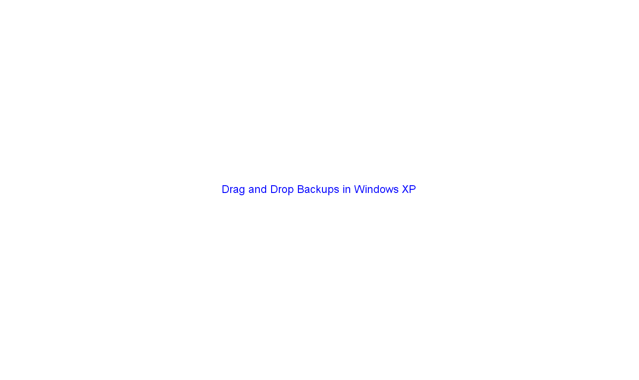

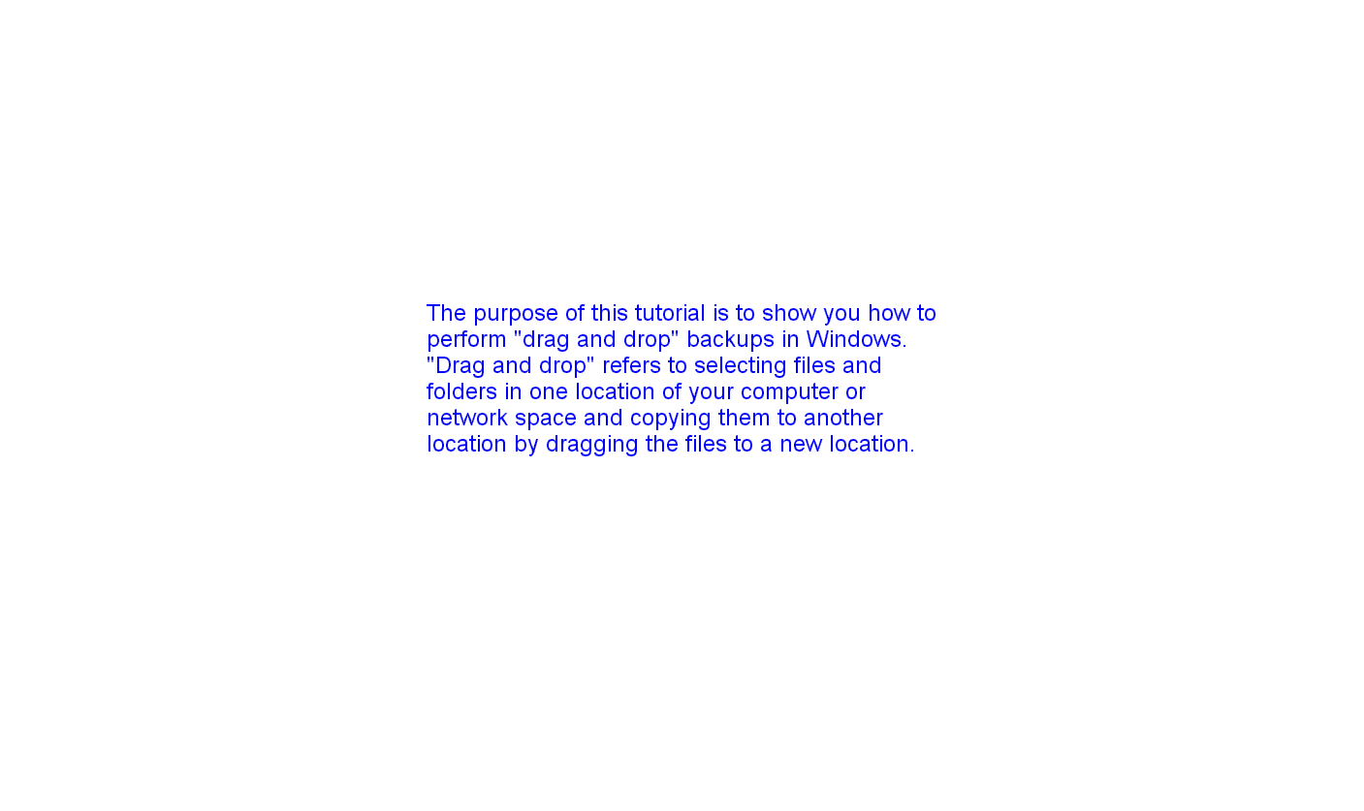

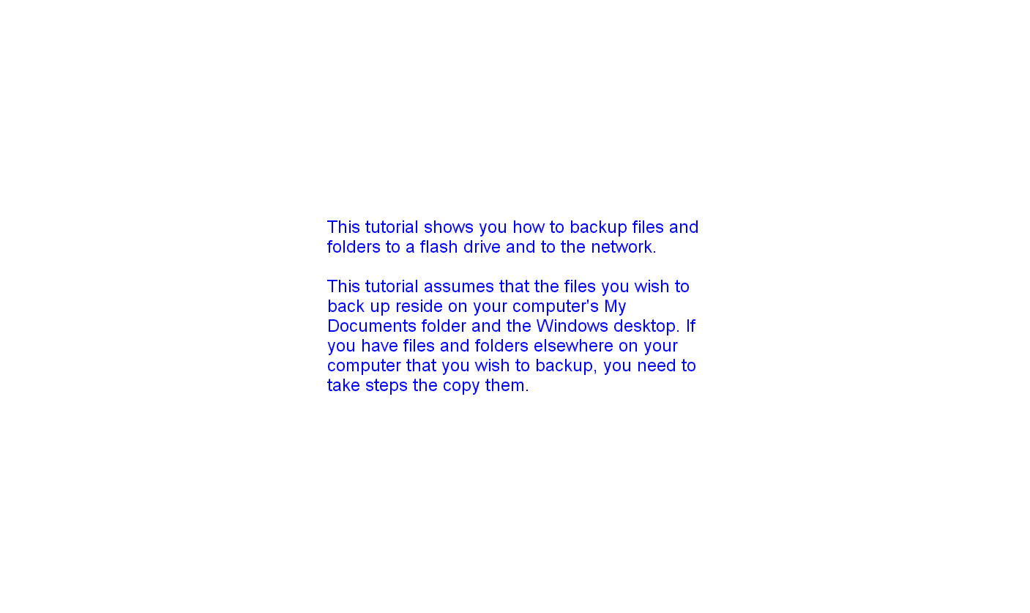

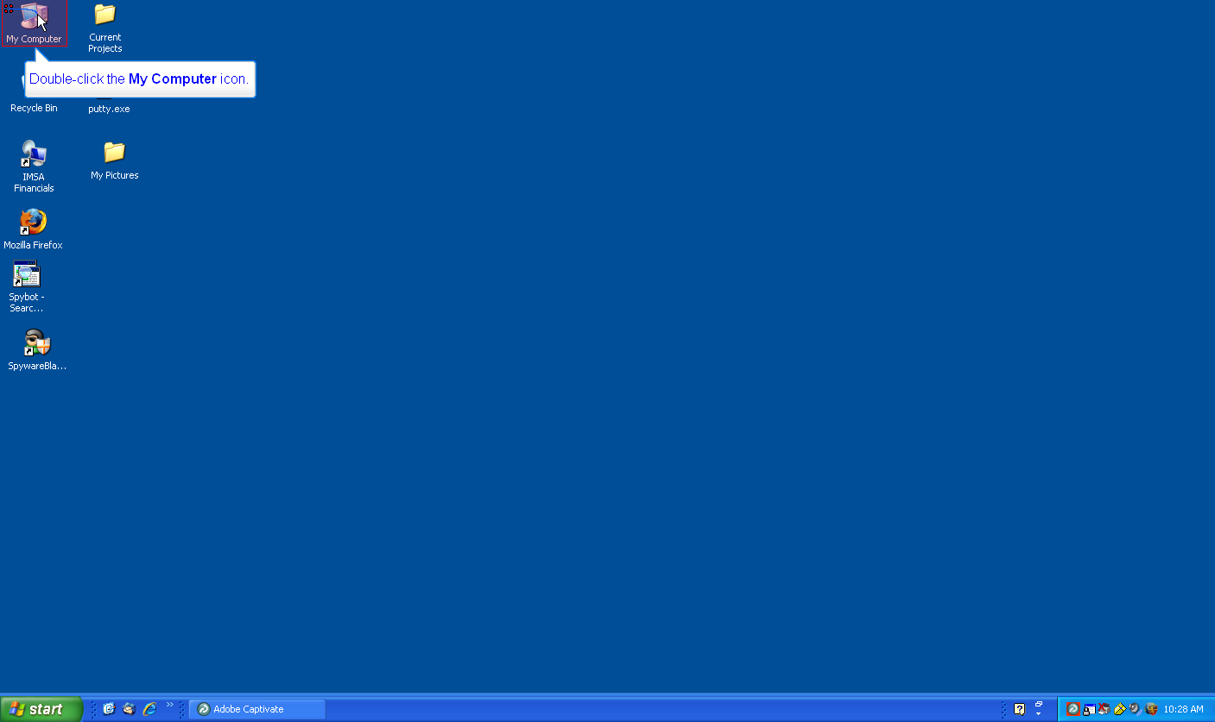

We'll begin by demonstrating how to backup files and folders to a flash drive. We'll
assume that the flash drive has been inserted into the USB port of your computer.

Double-click the 'My Computer' icon.

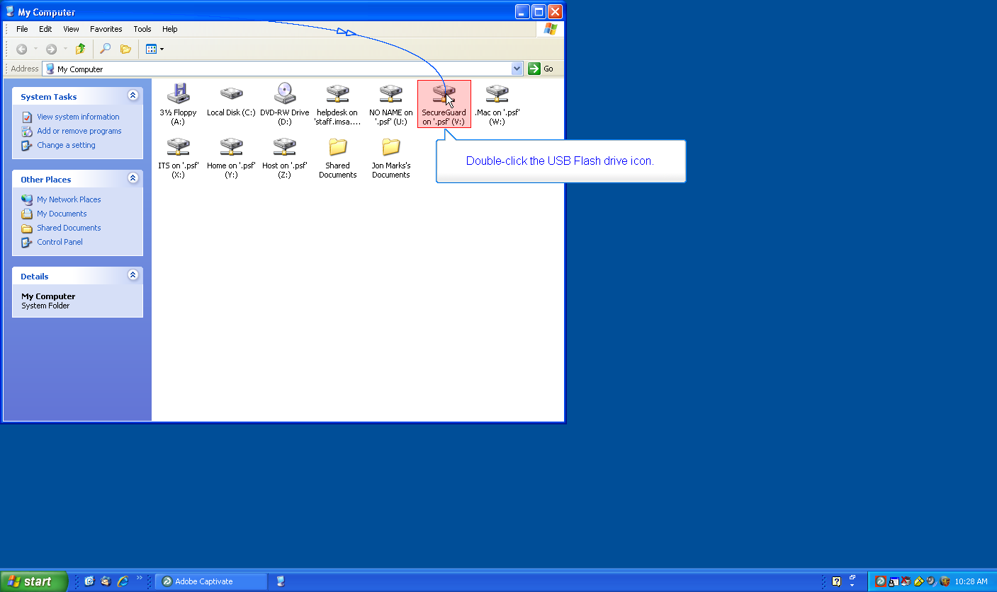

Double-click the USB flash drive icon.

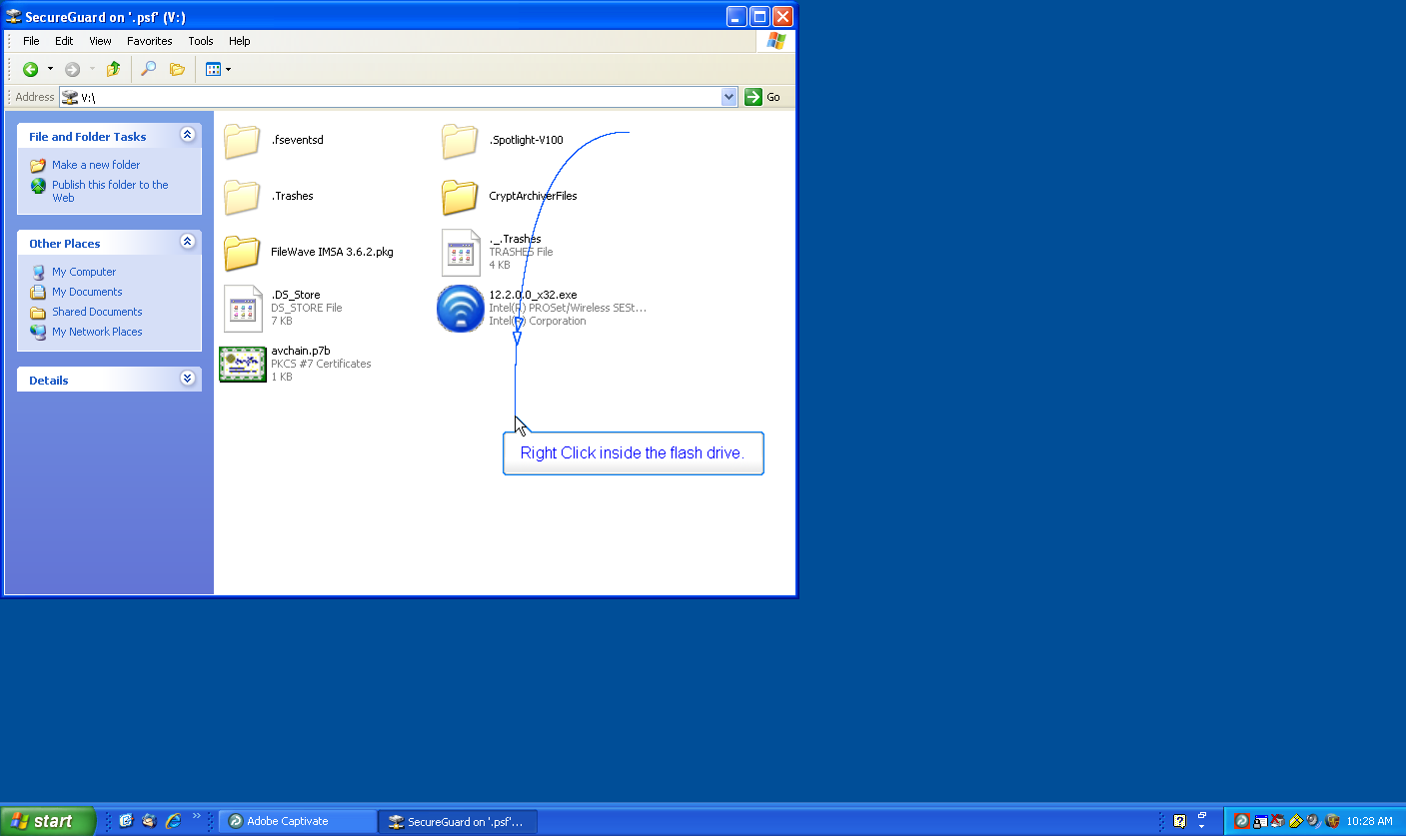

Next, we'll add a backup folder to the flash drive. Right Click inside the flash drive.

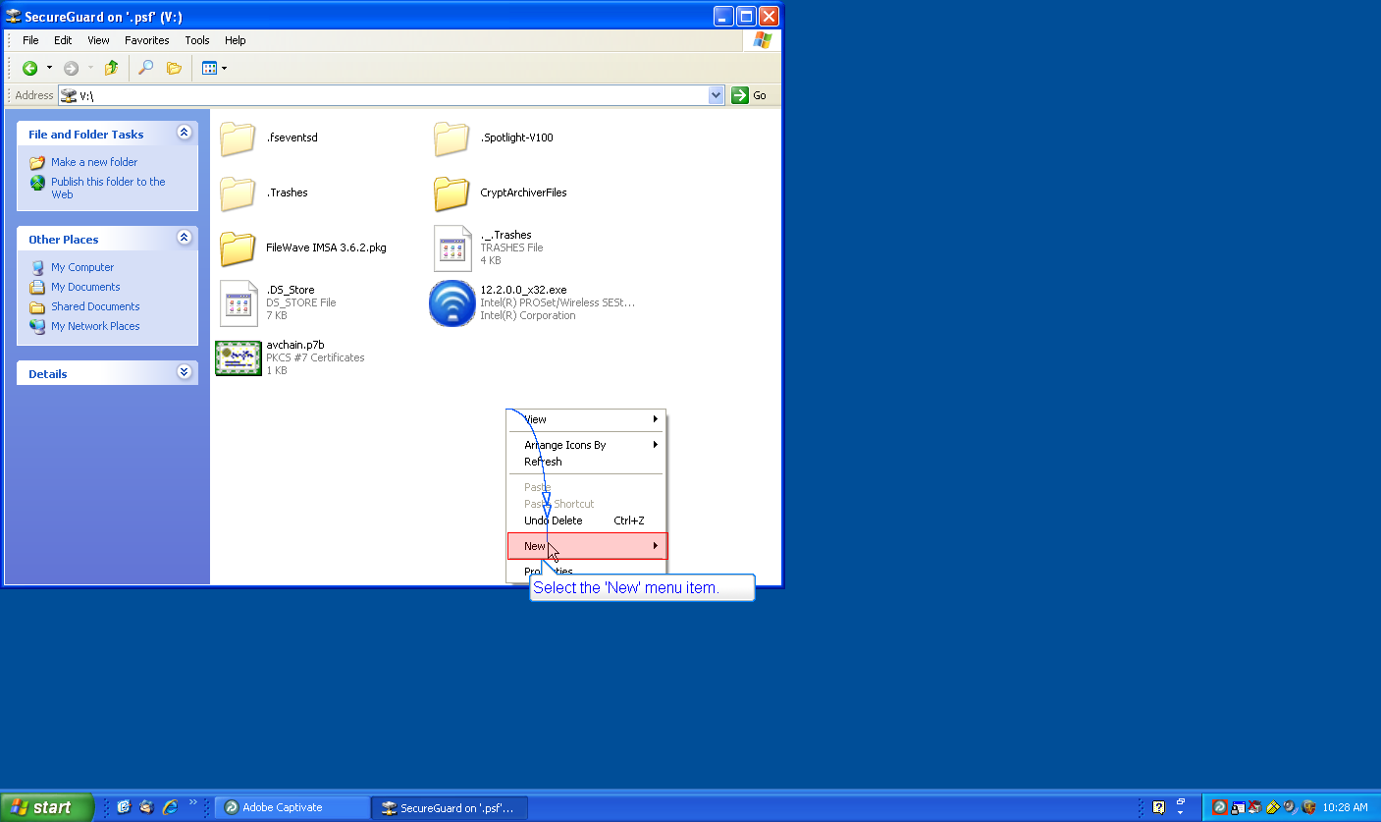

Select the 'New' menu item.

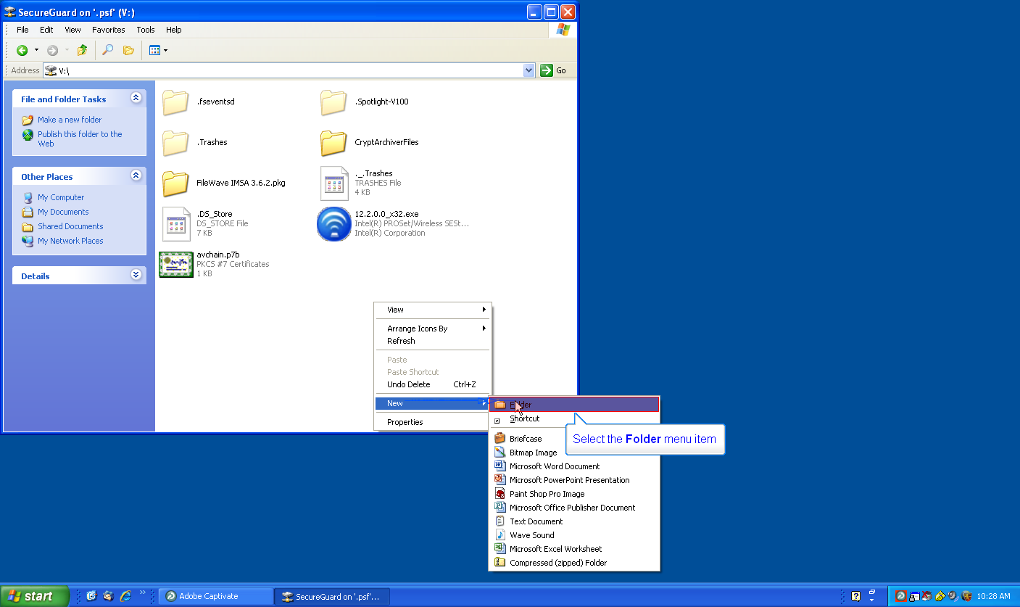

Select the Folder menu item.

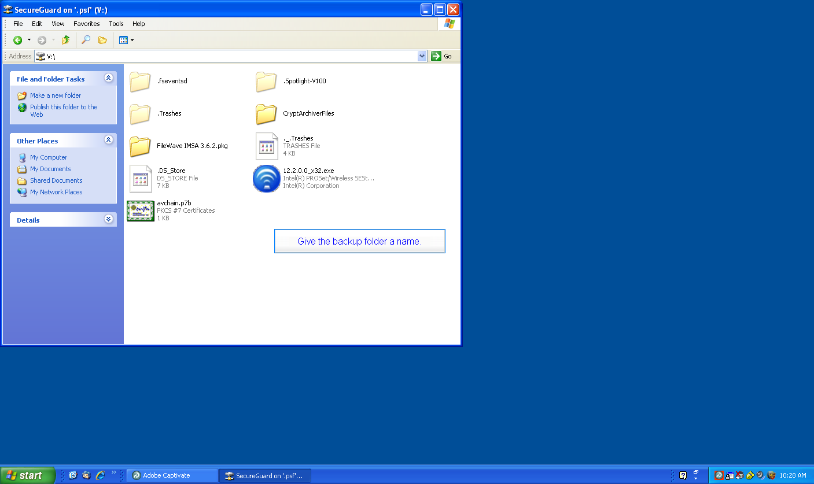

Give the backup folder a name.

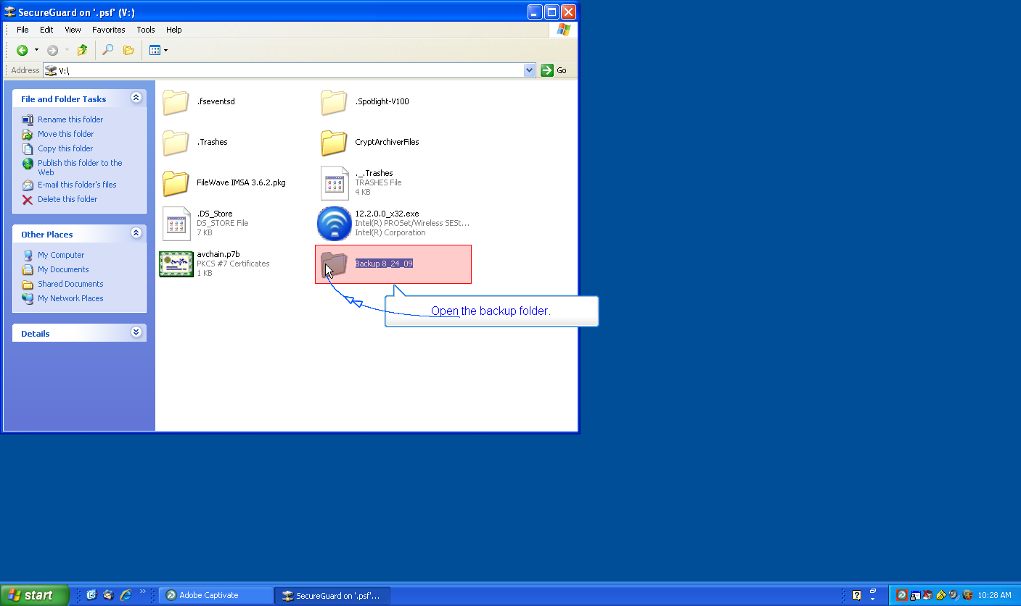

Open the backup folder.

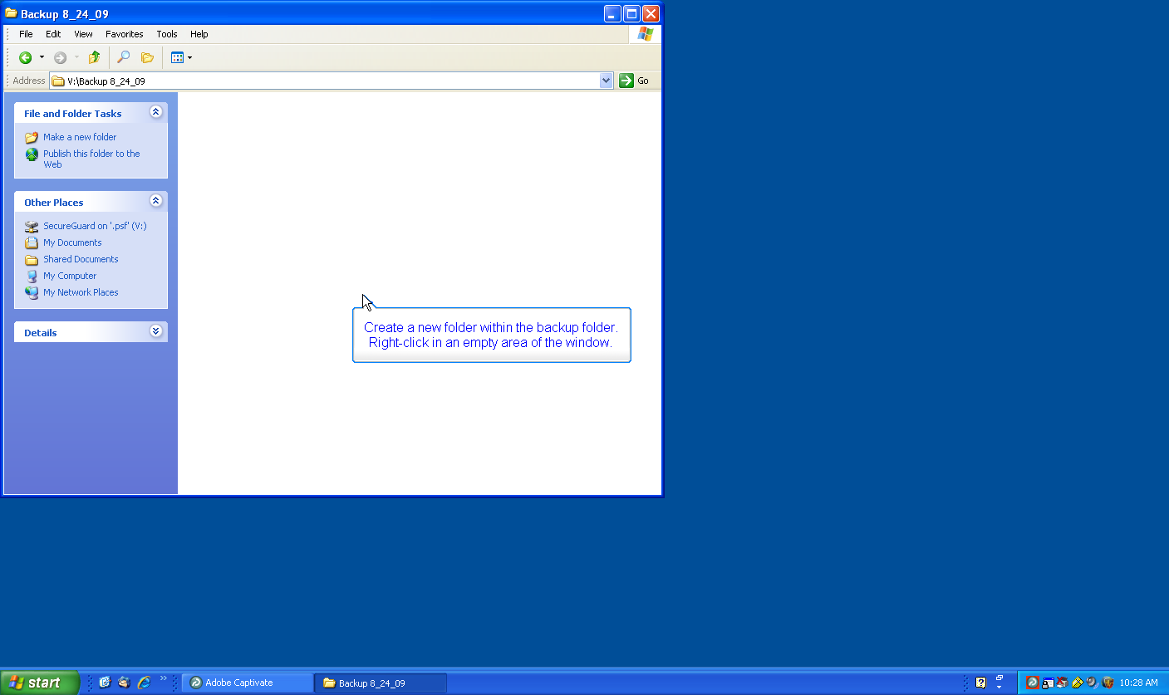

Create a new folder within the backup folder. Right-click in an empty area of the window.

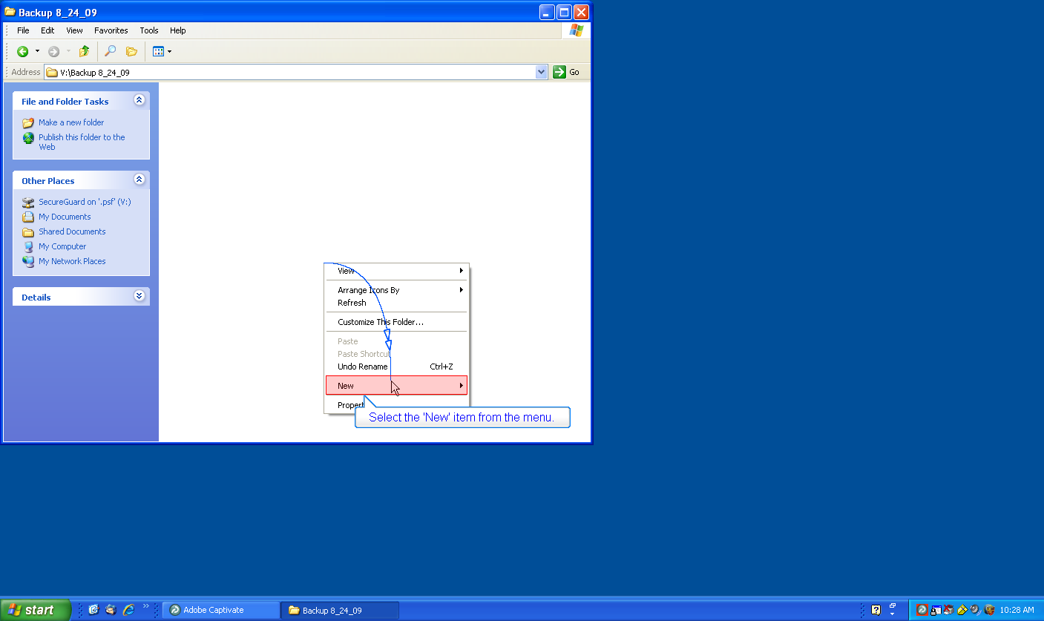

Select the 'New' item from the menu.

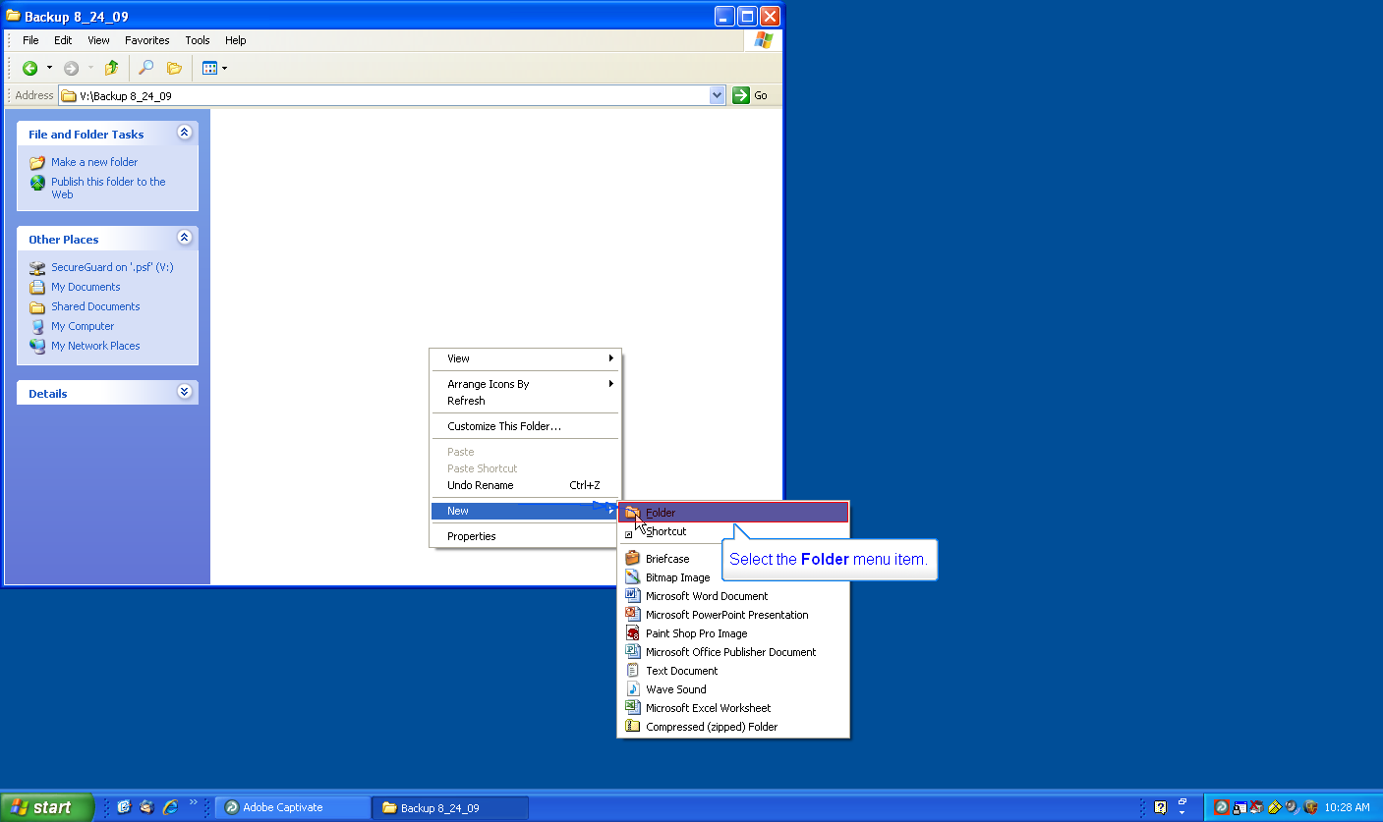

Select the Folder menu item.

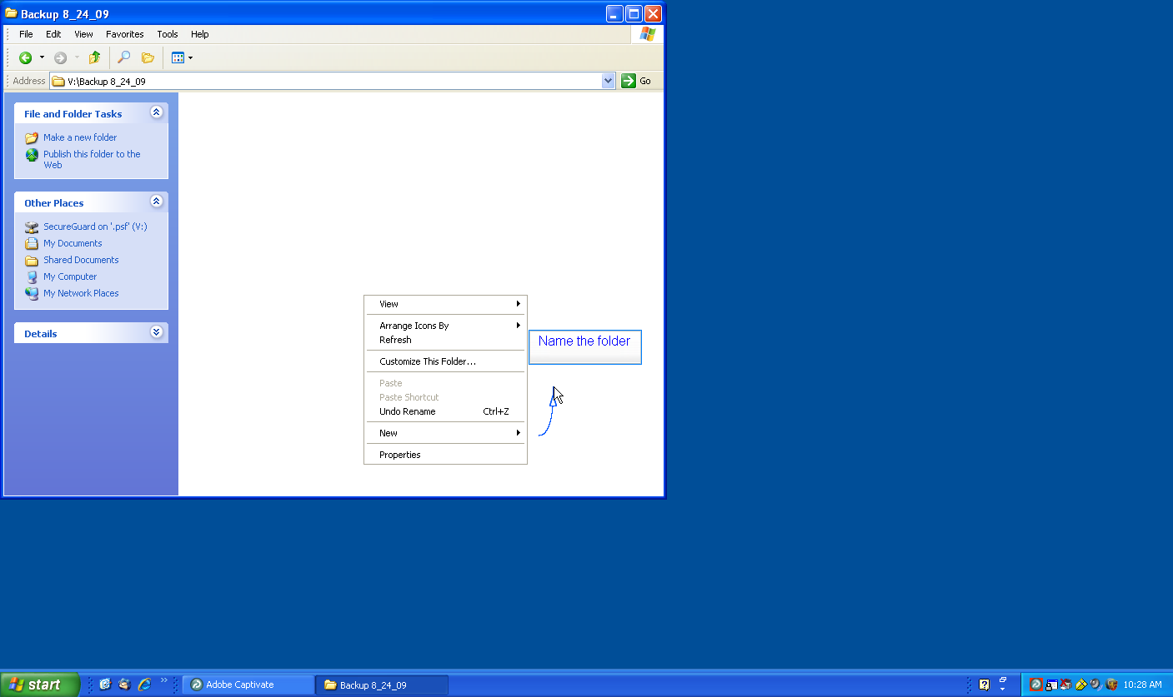

Name the folder 'My Documents'.

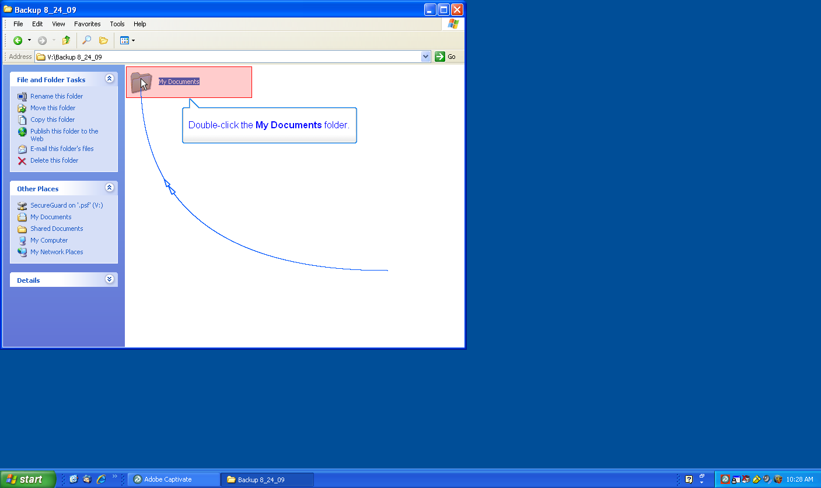

Double-click the My Documents folder.

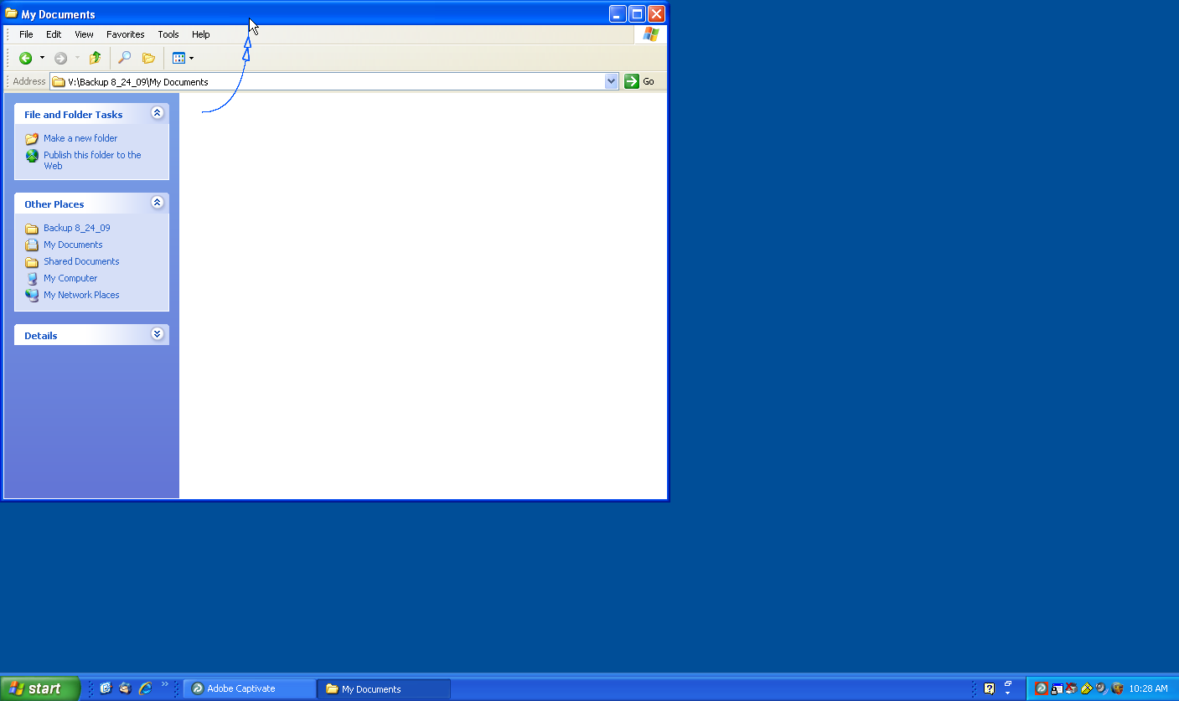

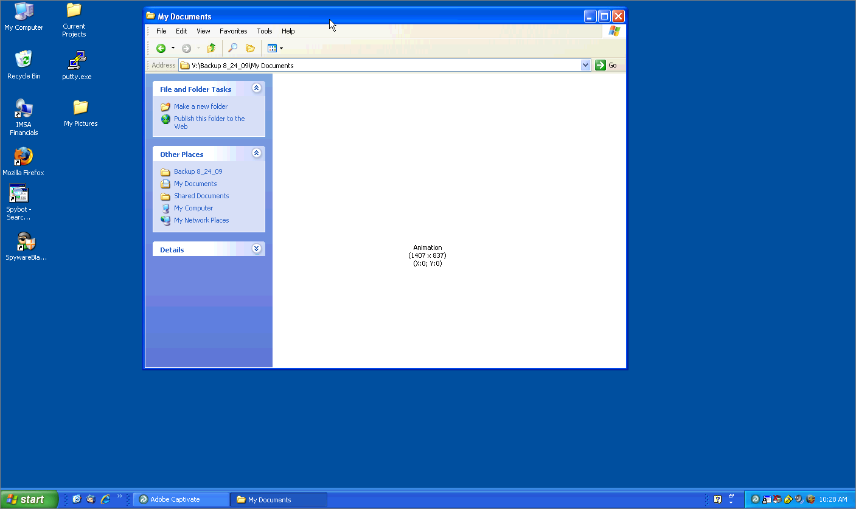

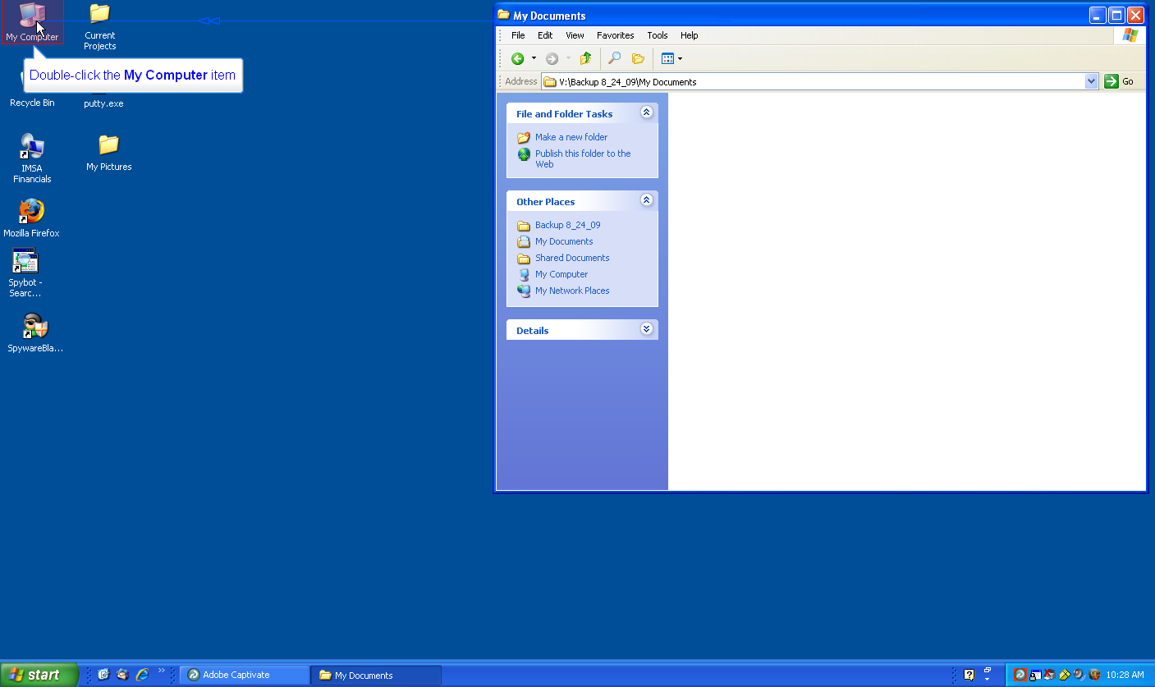

Now that we have set up the flash drive, we're now prepared to start copying the files from the 'My Documents' folder located on the computer.

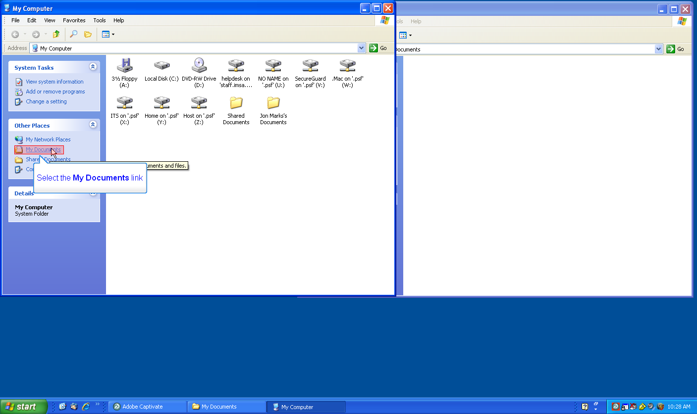

Select the My Documents link.

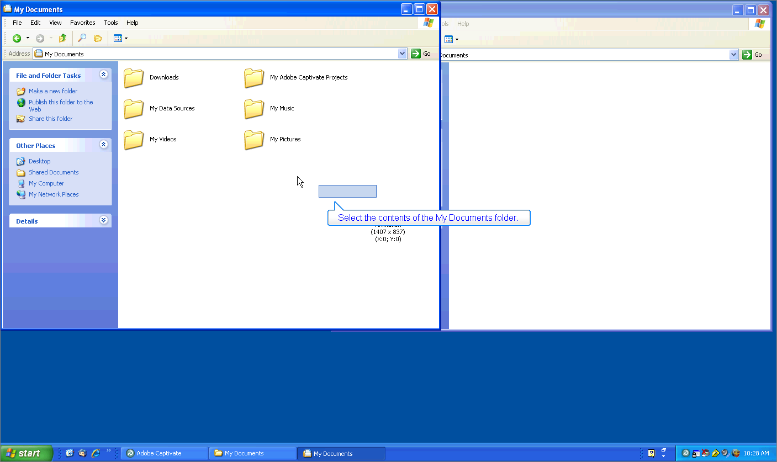

Select the contents of the My Documents folder.

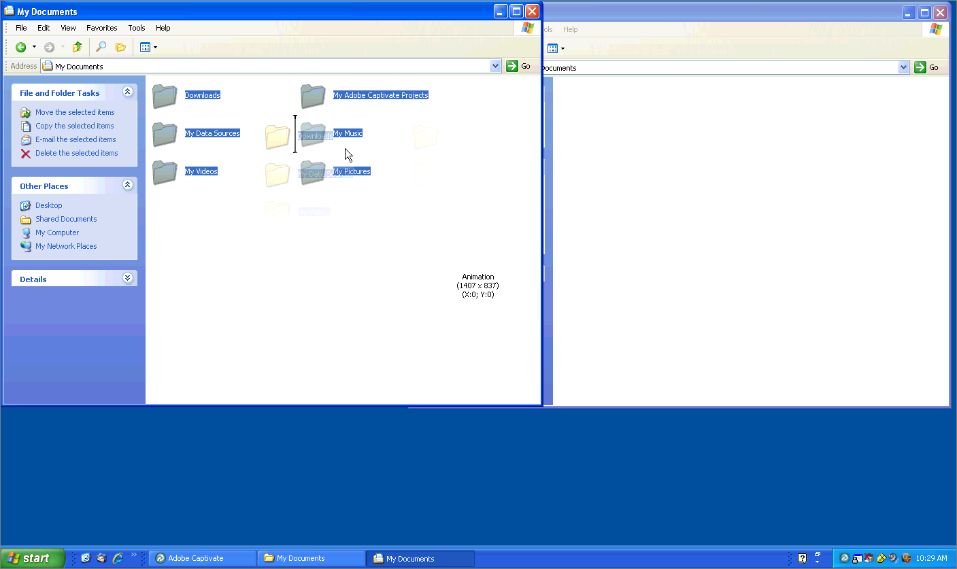

Drag and drop the selected files and folders in the My Documents folder on the computer to the 'My Documents' folder located on the flash drive.

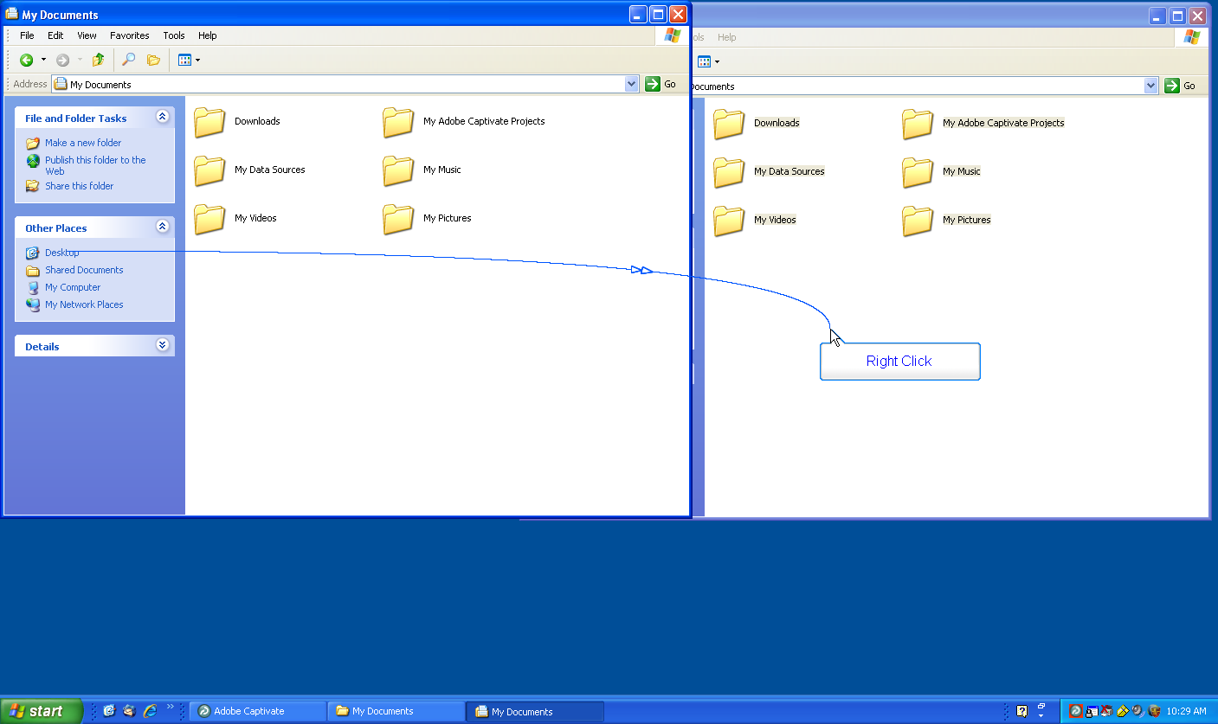

We now need to prepare to copy items from the desktop of the computer to the flash drive. We'll start by creating a folder on the flash drive. Right-click on the flash drive.

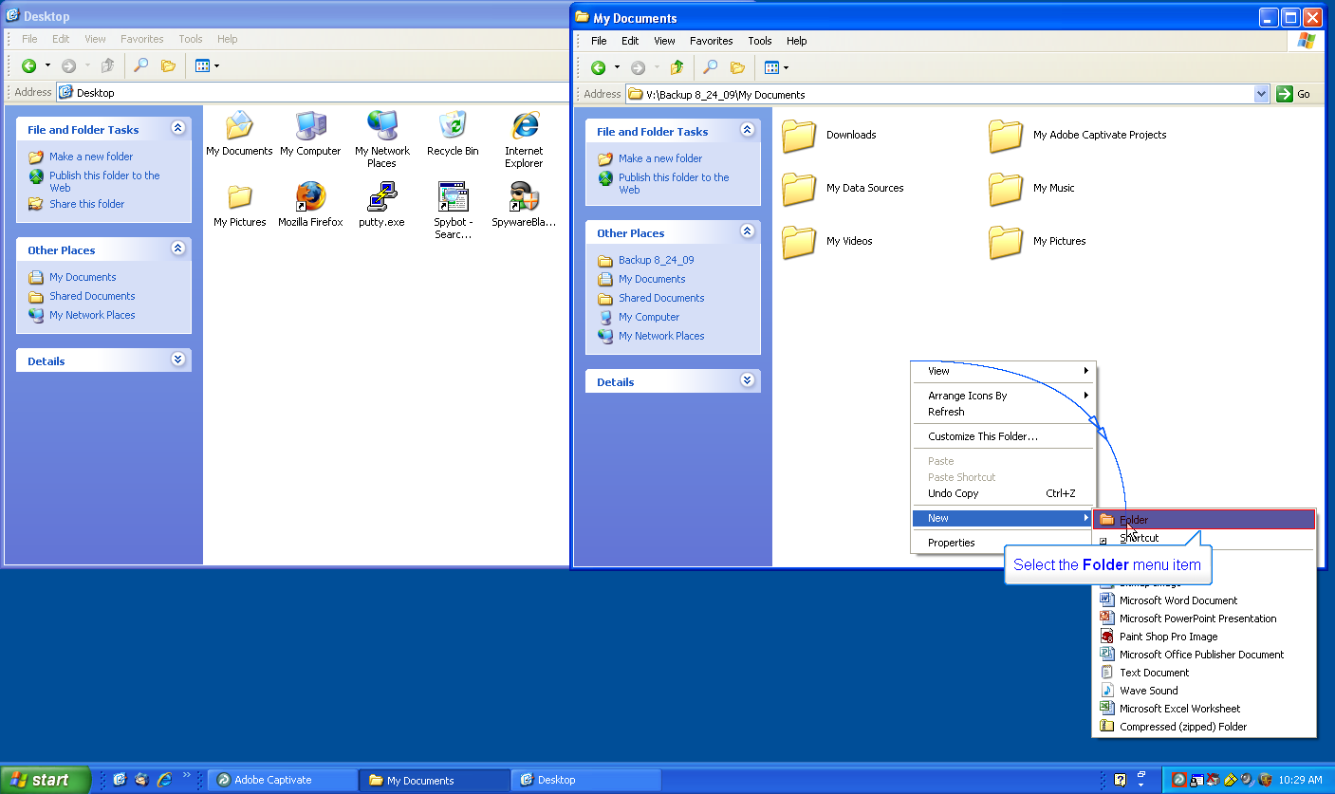

Select the Folder menu item

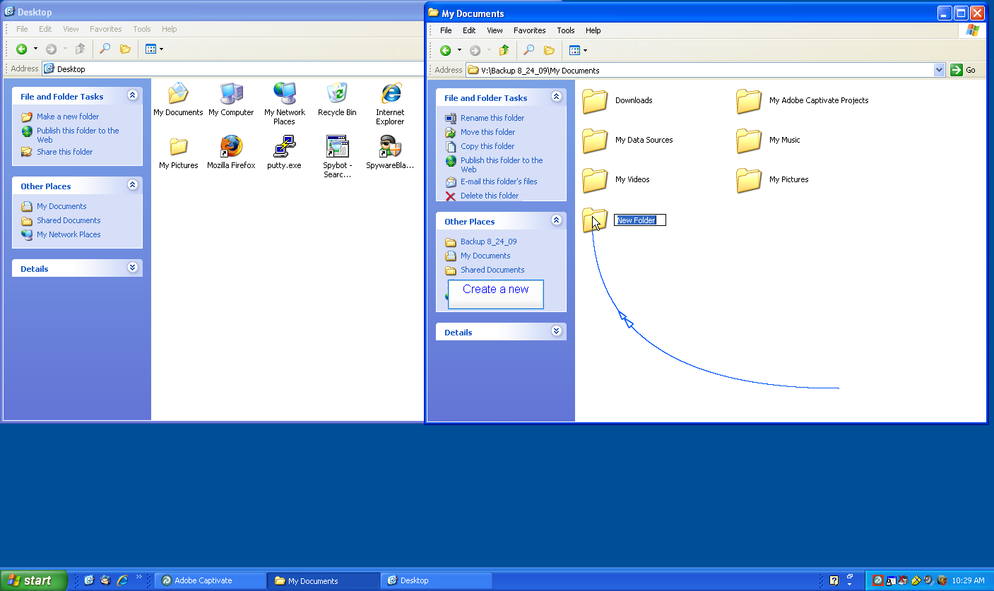

Create a new folder for your desktop items.

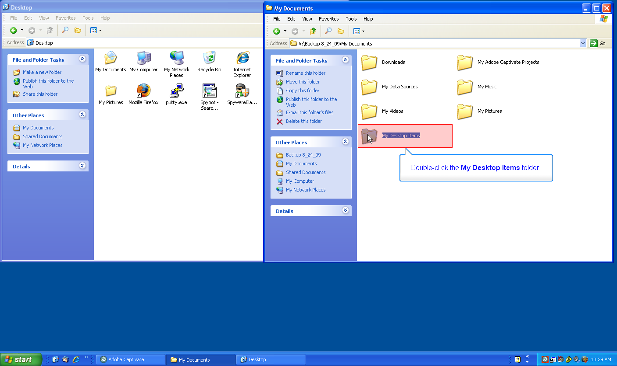

Double-click the My Desktop Items folder.

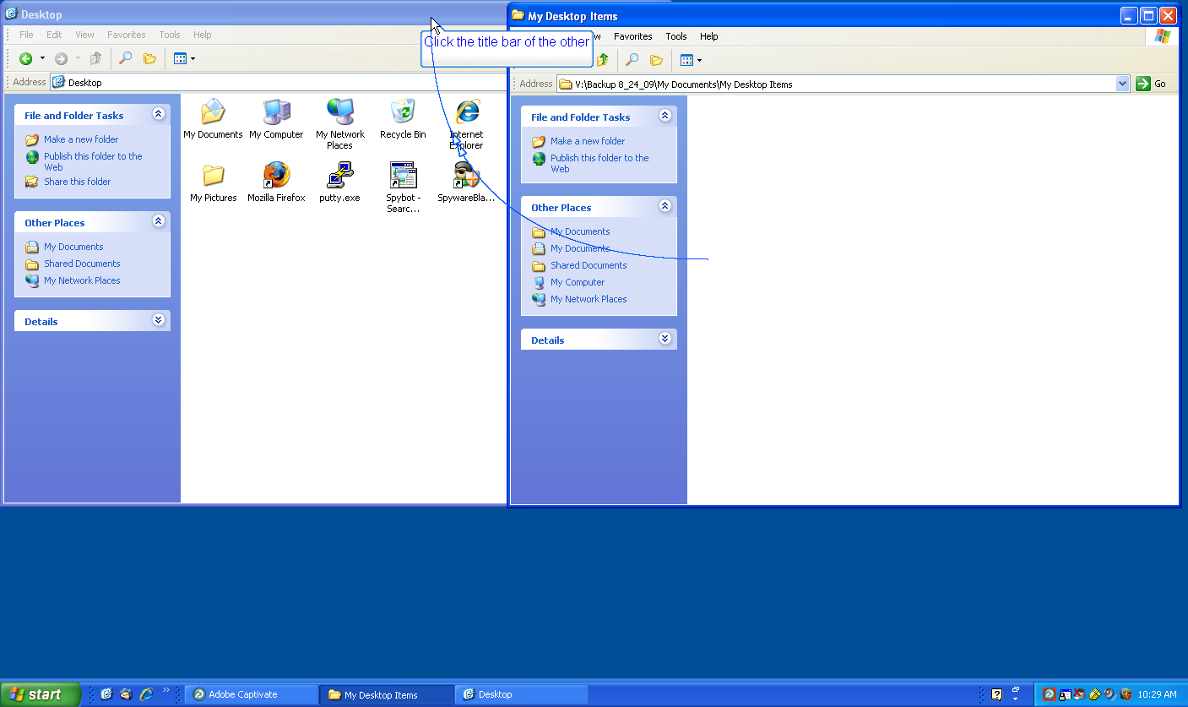

Click the title bar of the other window.

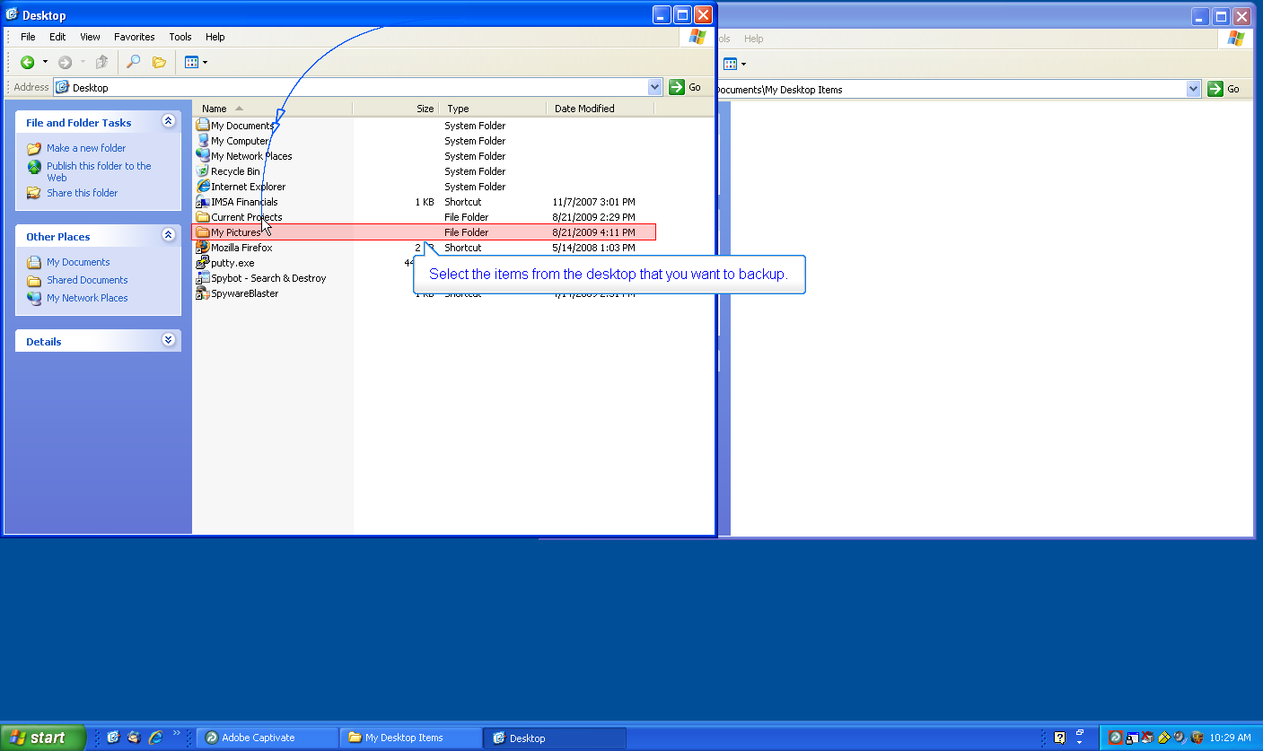

Select the items from the desktop that you want to backup.

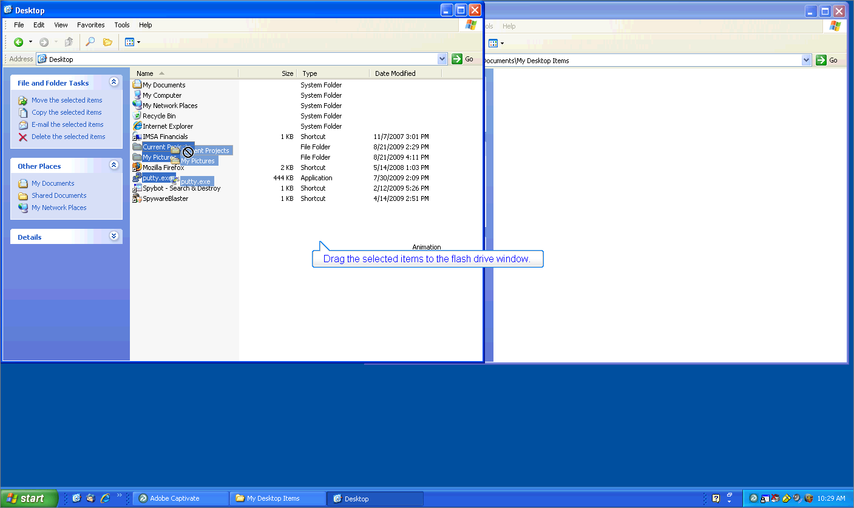

Drag the selected items to the flash drive window.

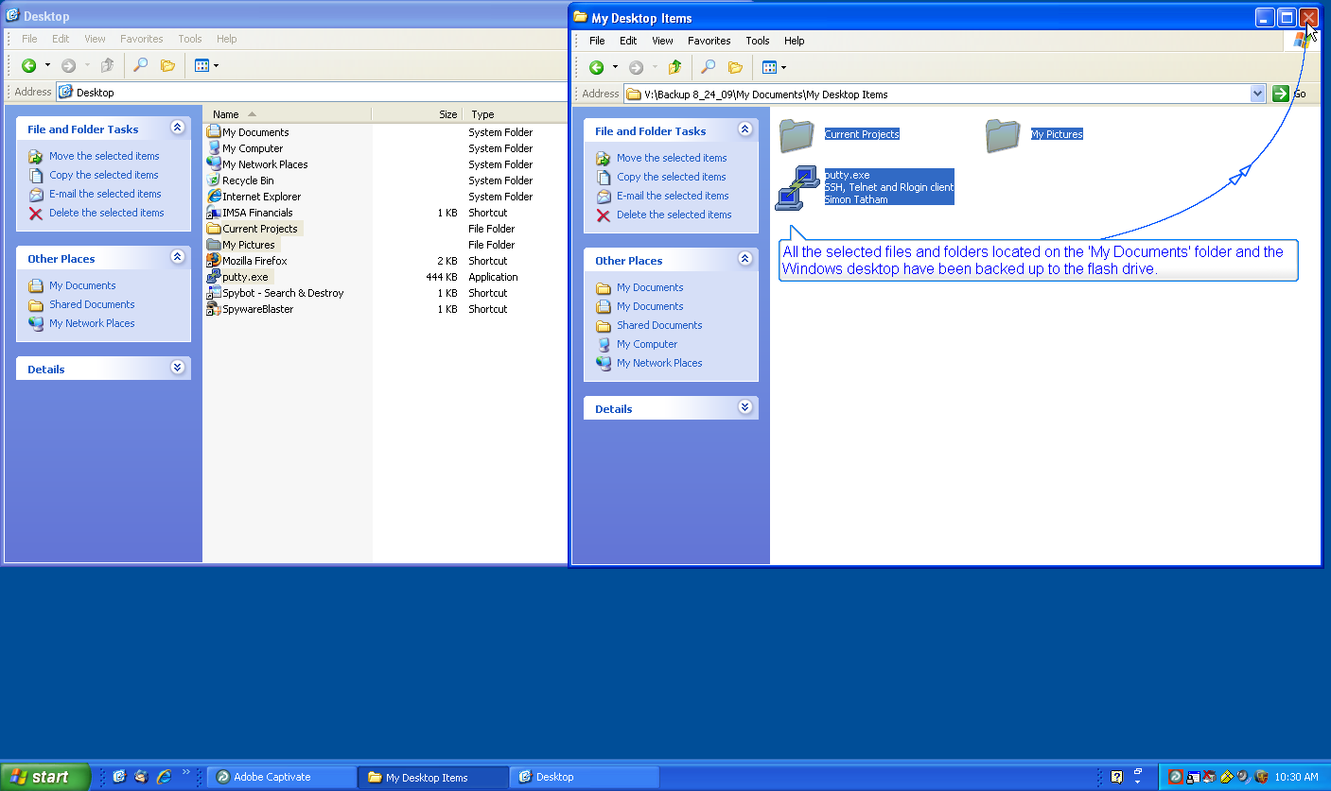

All the selected files and folders located on the 'My Documents' folder and the Windows desktop have been backed up to the flash drive.

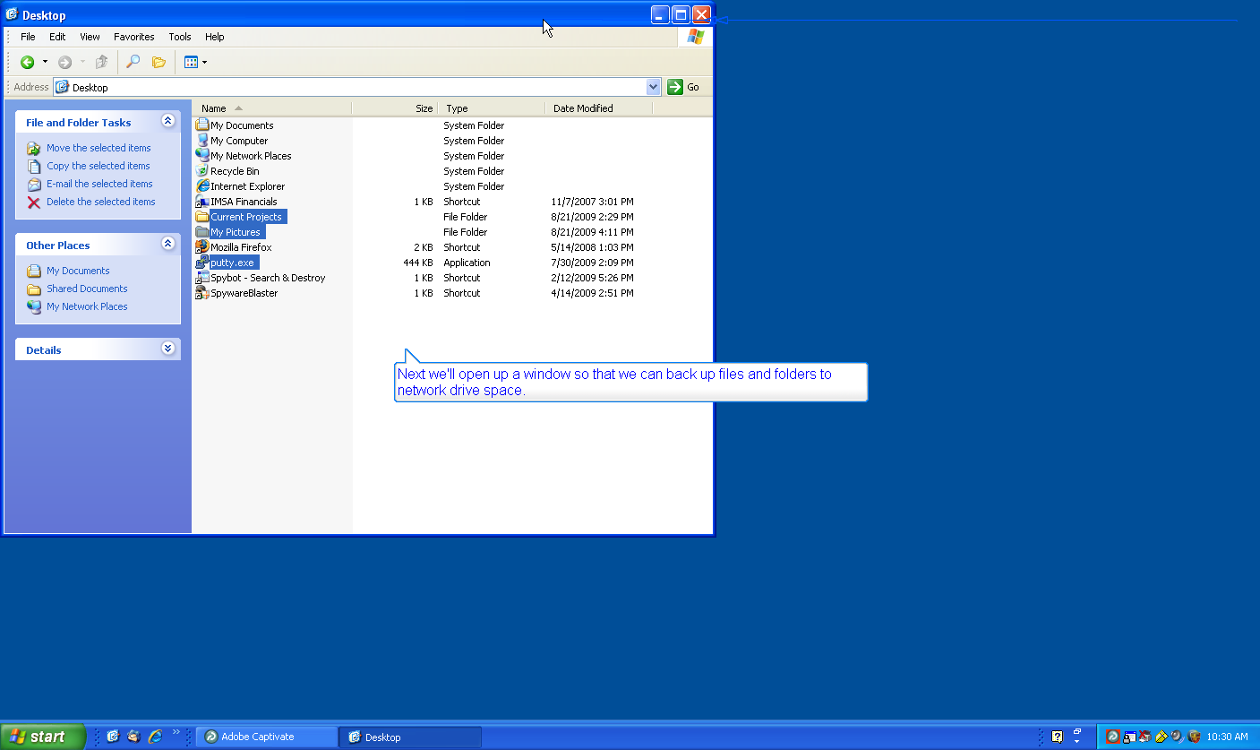

Next we'll open up a window so that we can back up files and folders to network drive space.

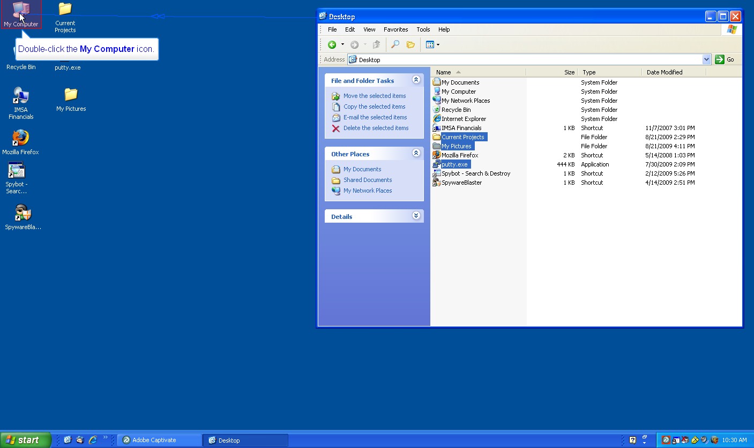

Double-click the My Computer icon.

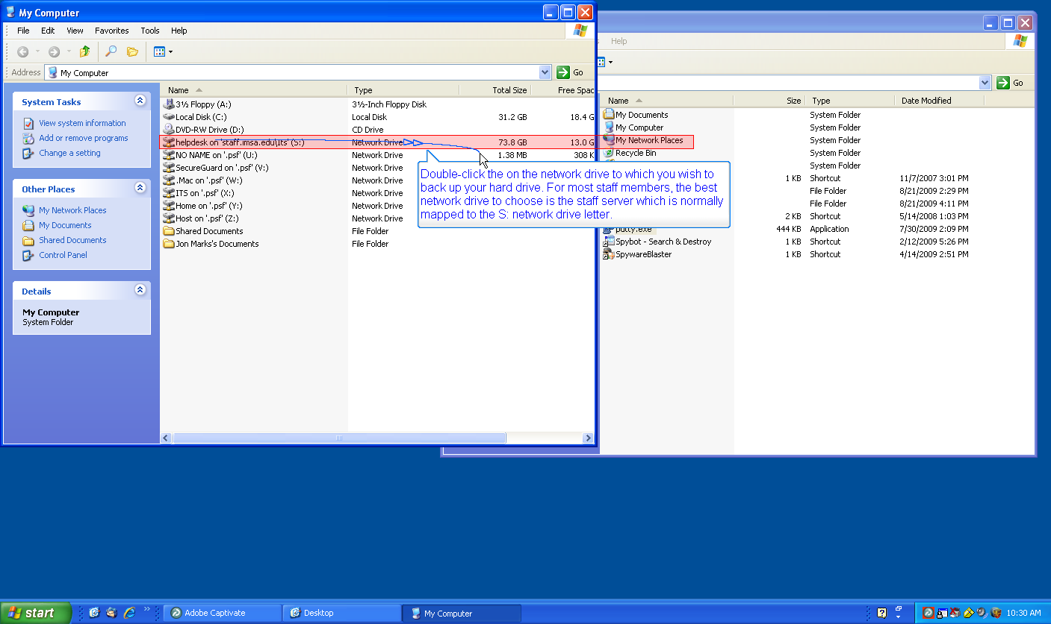

Double-click the on the network drive to which you wish to back up your hard drive. For most staff members, the best network drive to choose is the staff server which is normally mapped to the S: network drive letter.

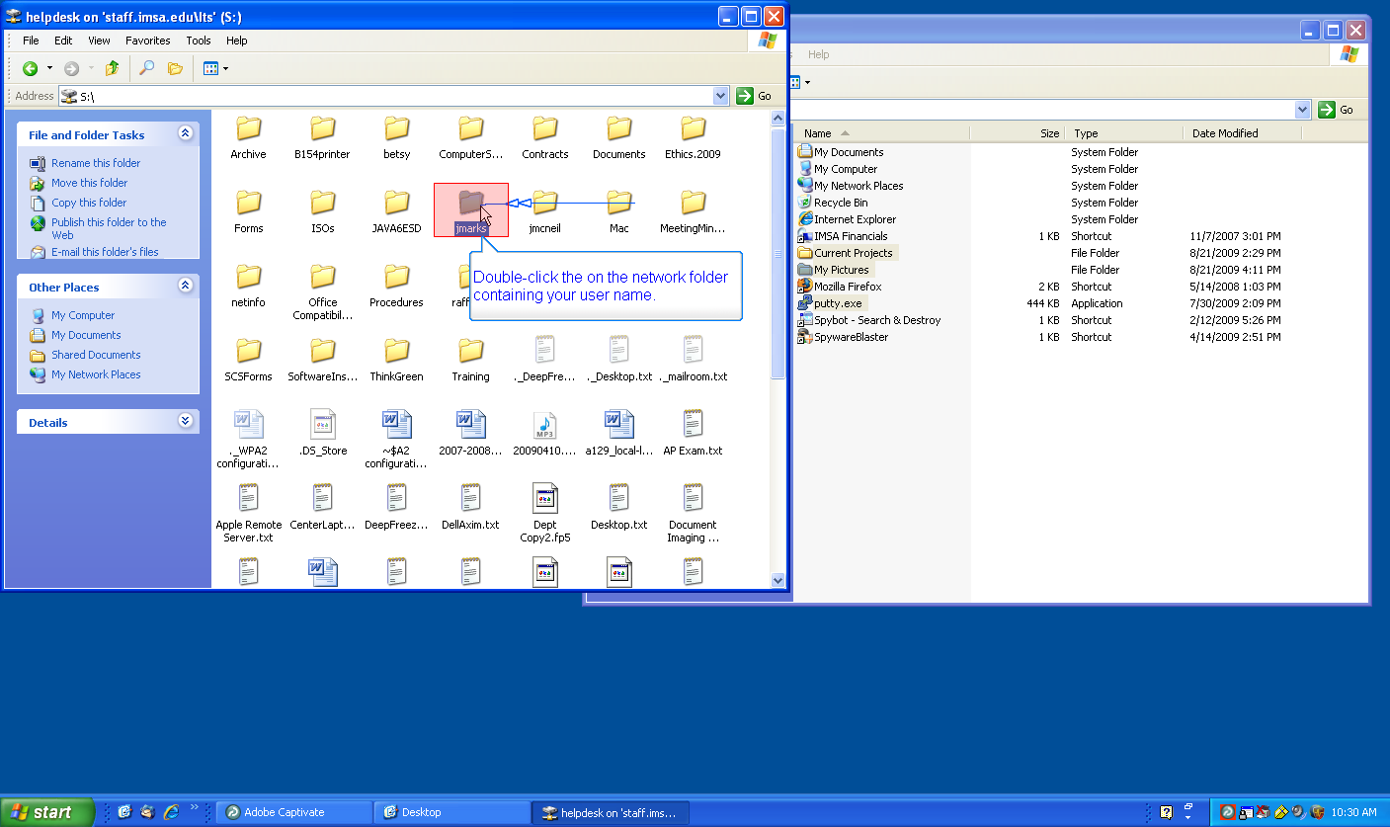

Double-click the on the network folder containing your user name.

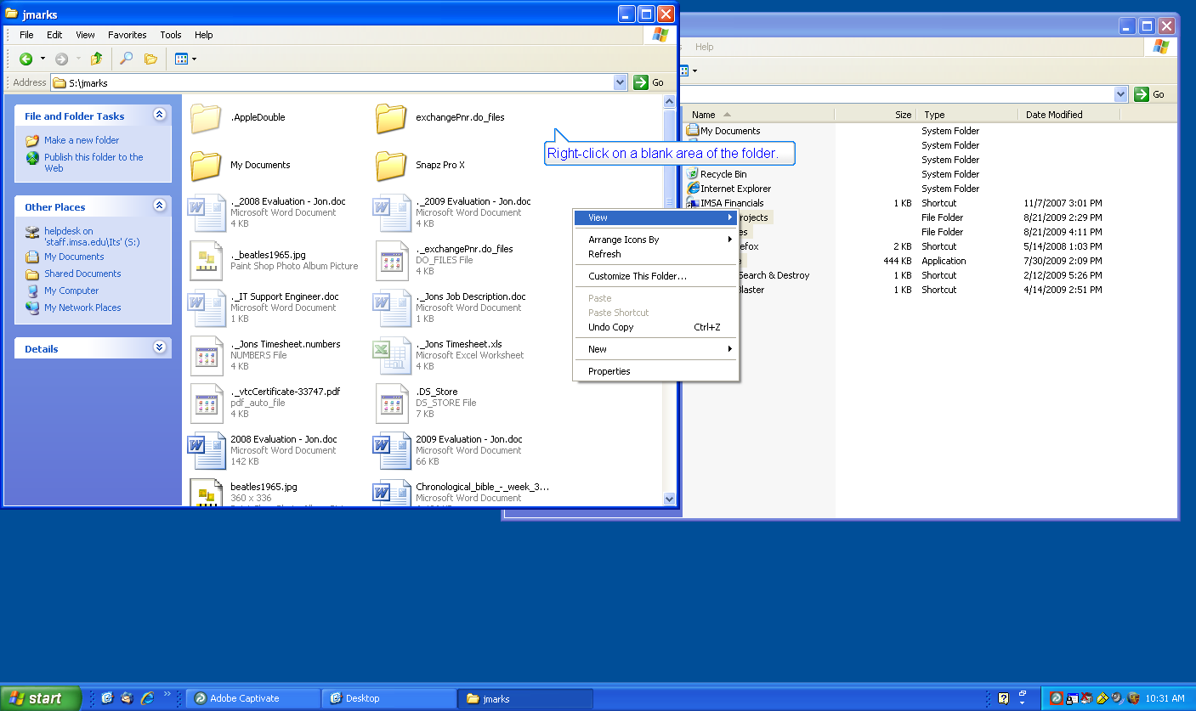

Right-click on a blank area of the folder.

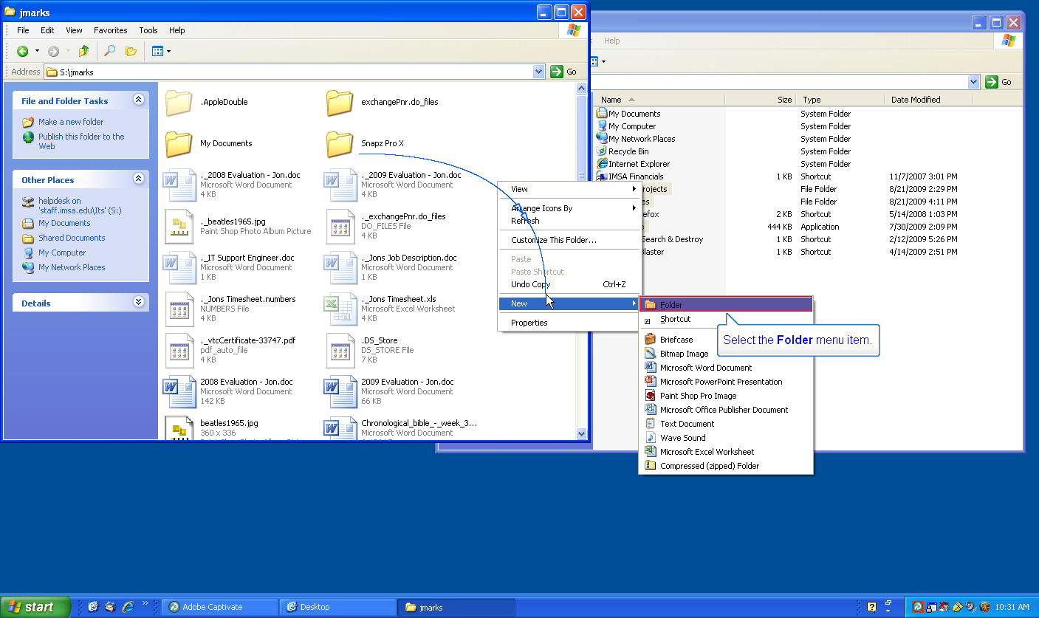

Select the Folder menu item.

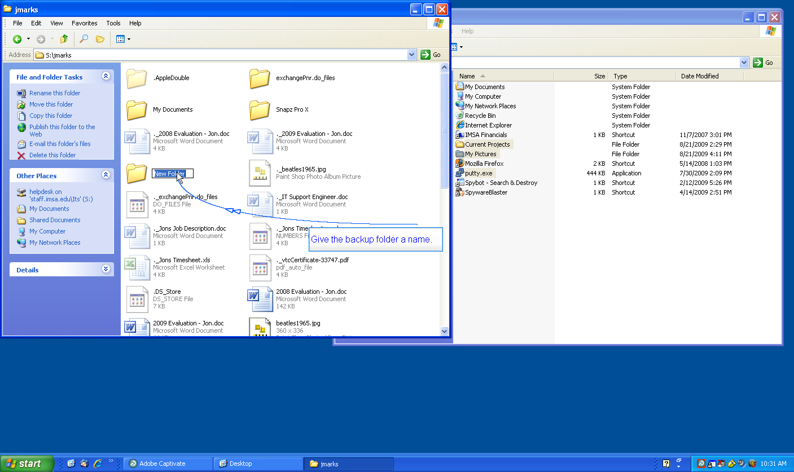

Give the backup folder a name.

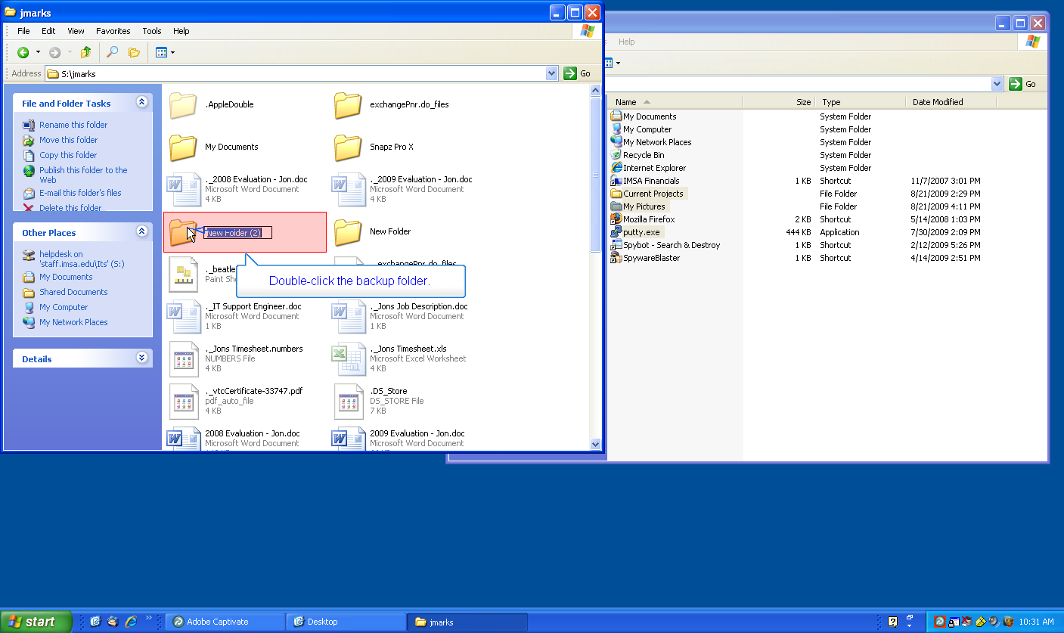

Double-click the backup folder.

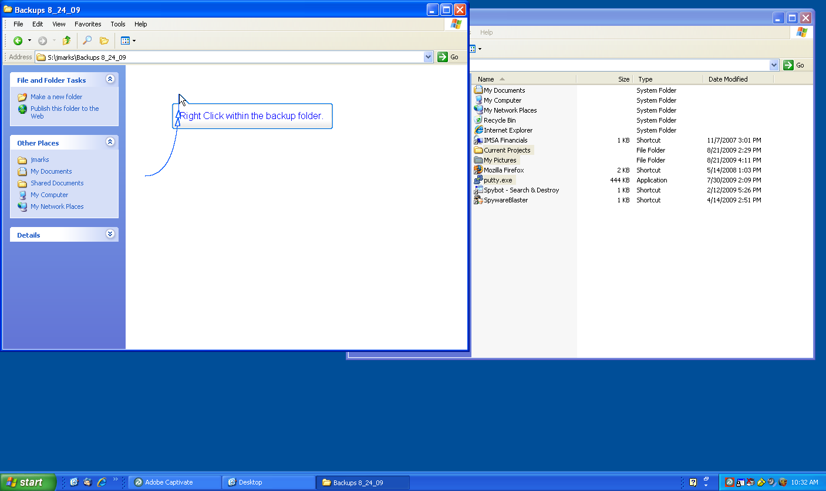

Right Click within the backup folder.

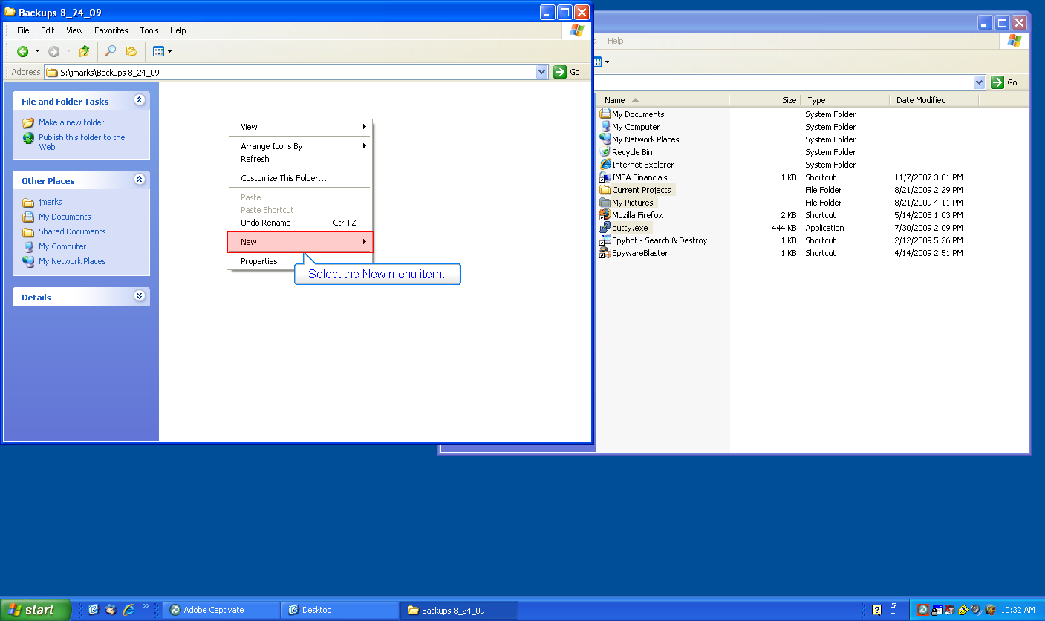

Select the New menu item.

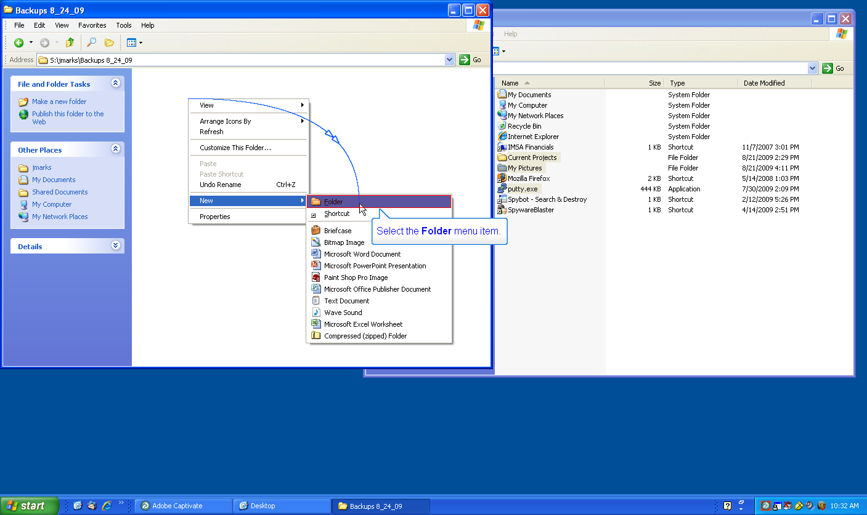
1
Select the Folder menu item.

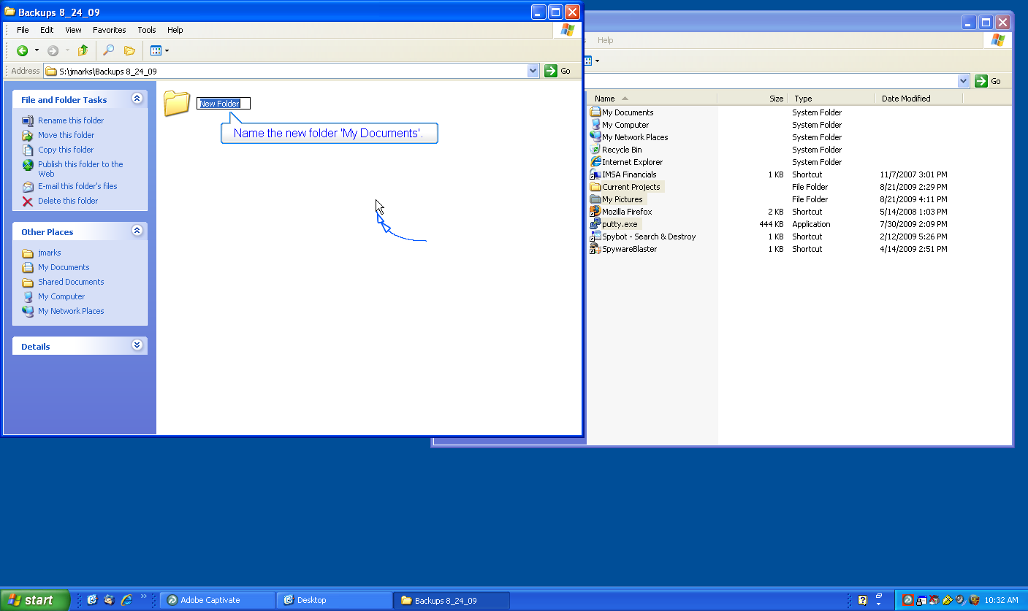

Name the new folder 'My Documents'.

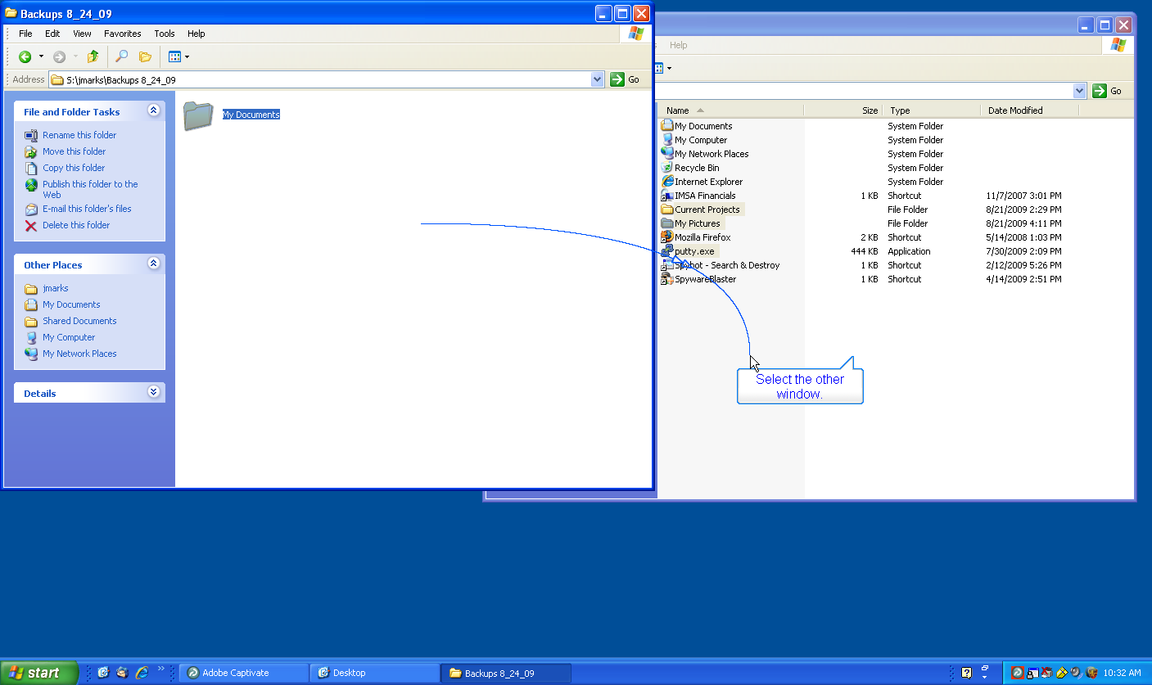

Select the other window.

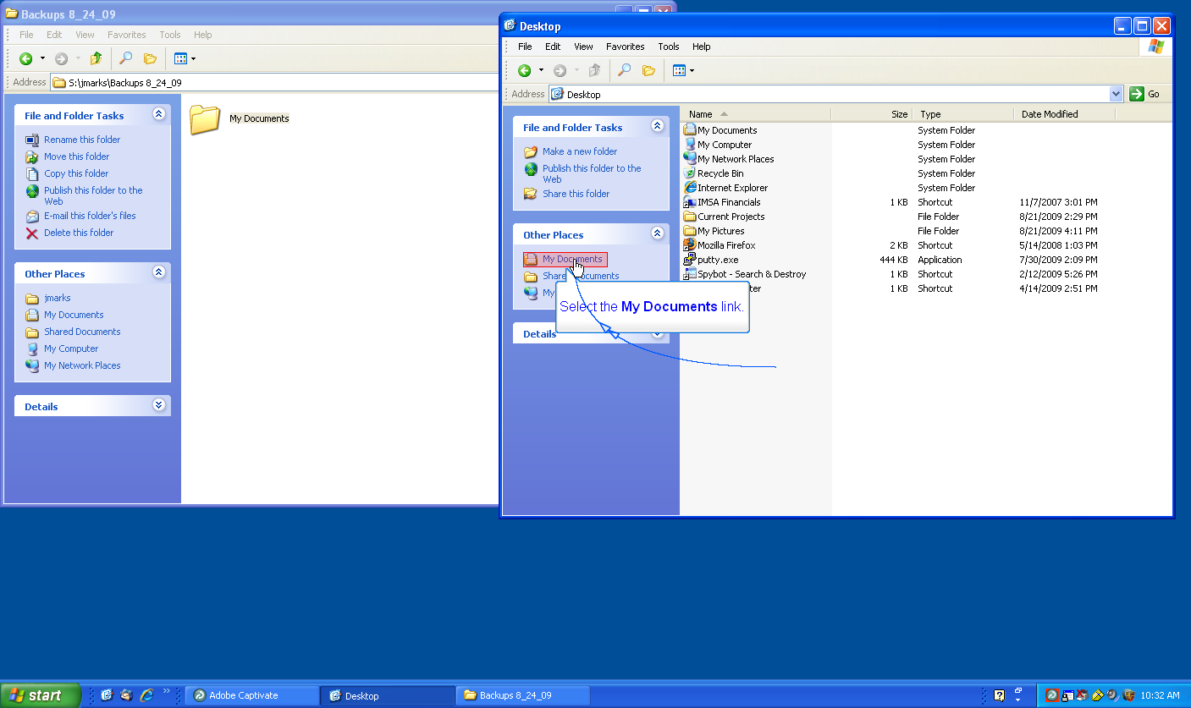

Select the My Documents link.

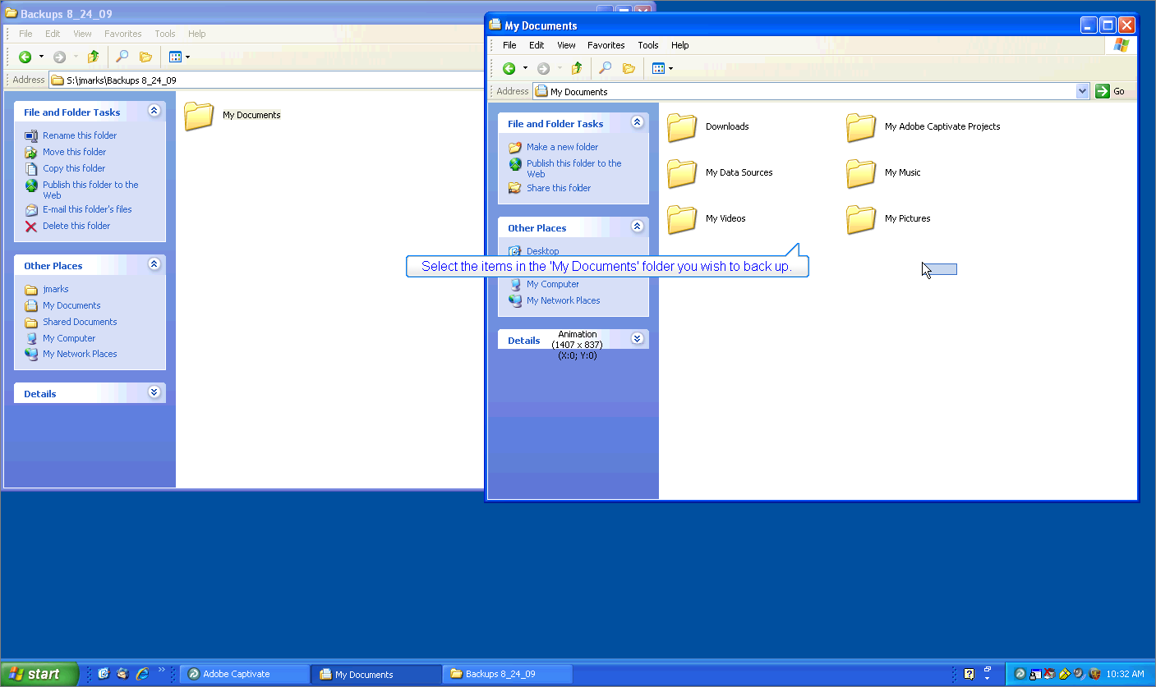

Select the items in the 'My Documents' folder that you wish to back up.

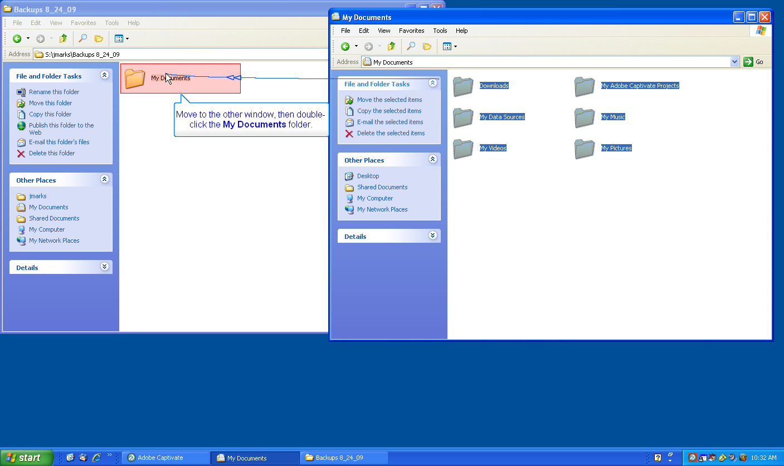

Move to the other window, then double-click the My Documents folder.

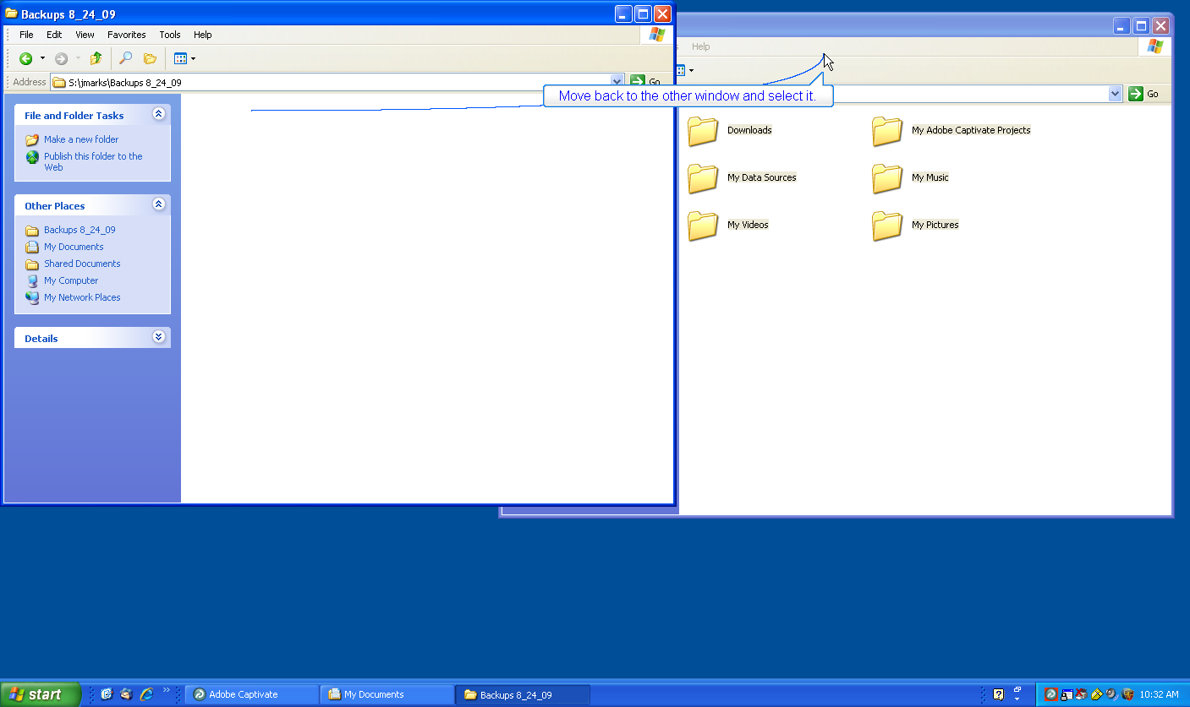

Move back to the other window and select it.

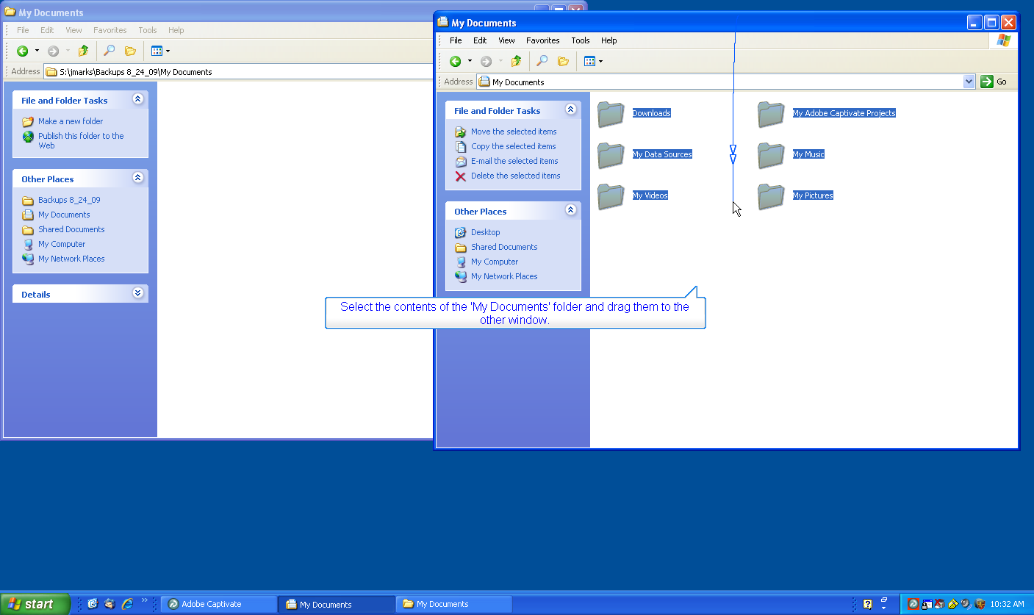

Select the contents of the 'My Documents' folder and drag them to the other window.

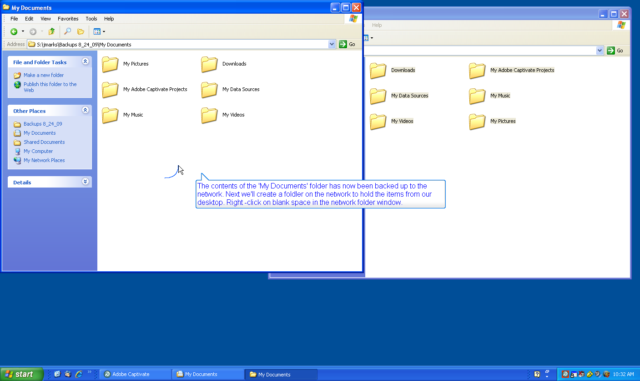

The contents of the 'My Documents' folder has now been backed up to the network. Next we'll create a folder on the network to hold the items from our desktop. Right -click on blank space in the network folder window.

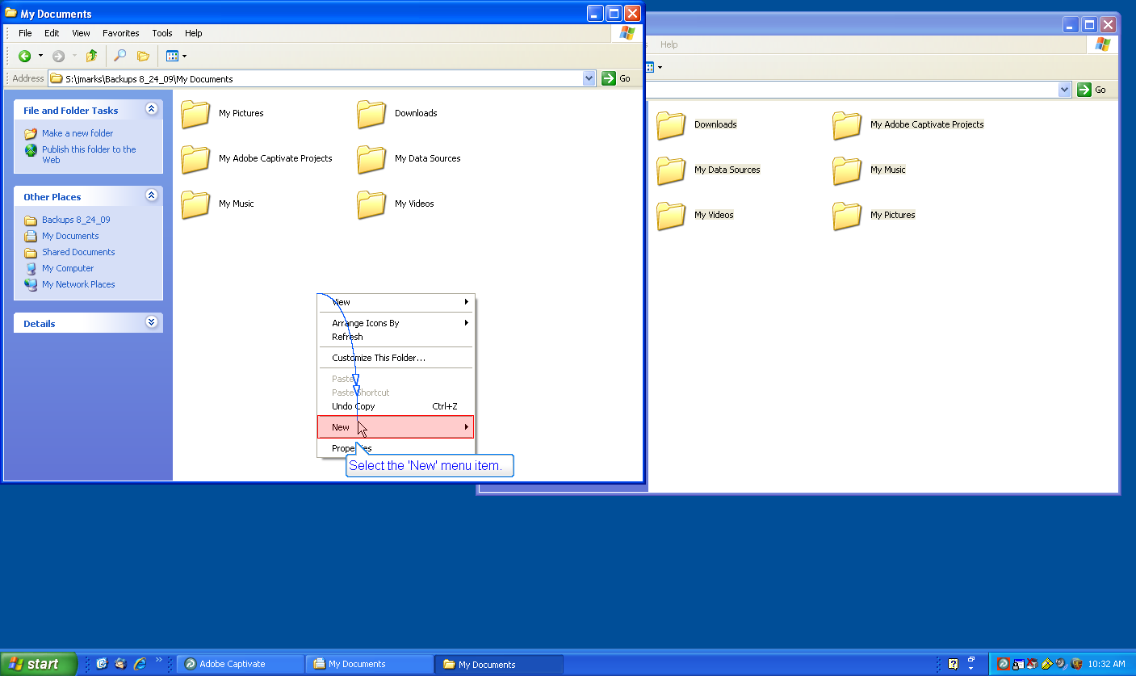

Select the 'New' menu item.

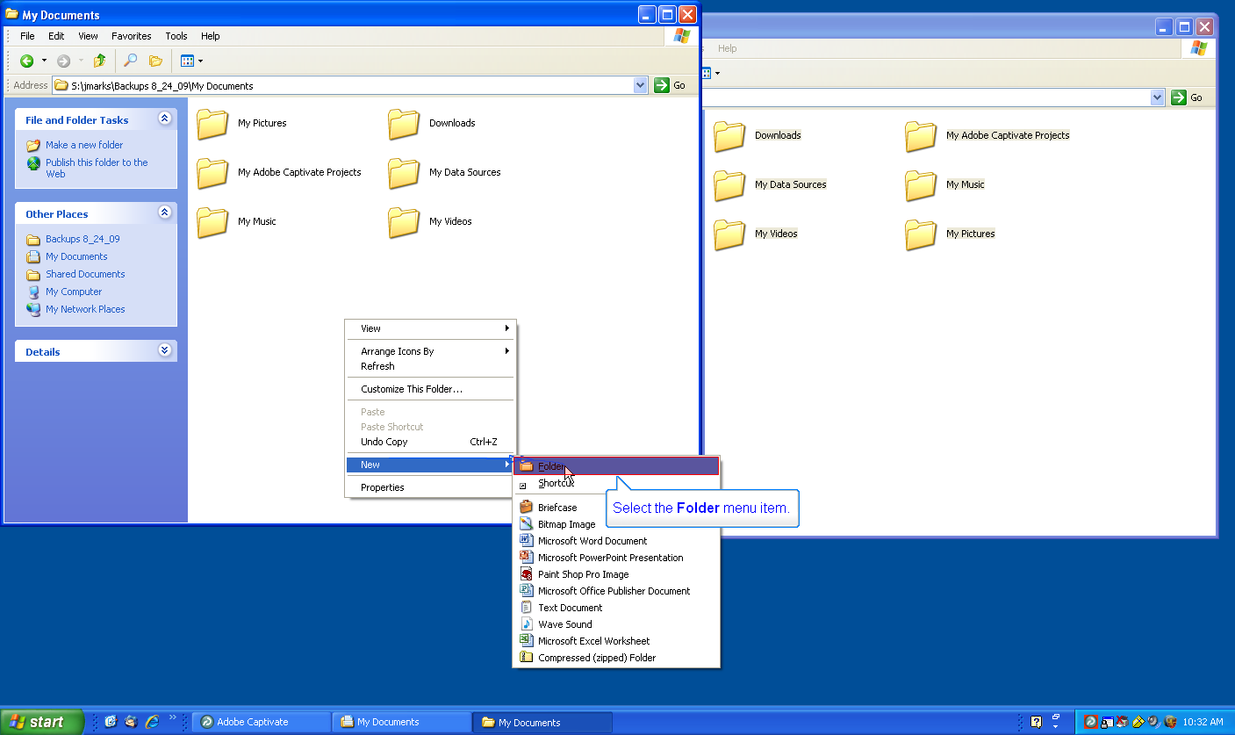

Select the 'Folder' menu item.

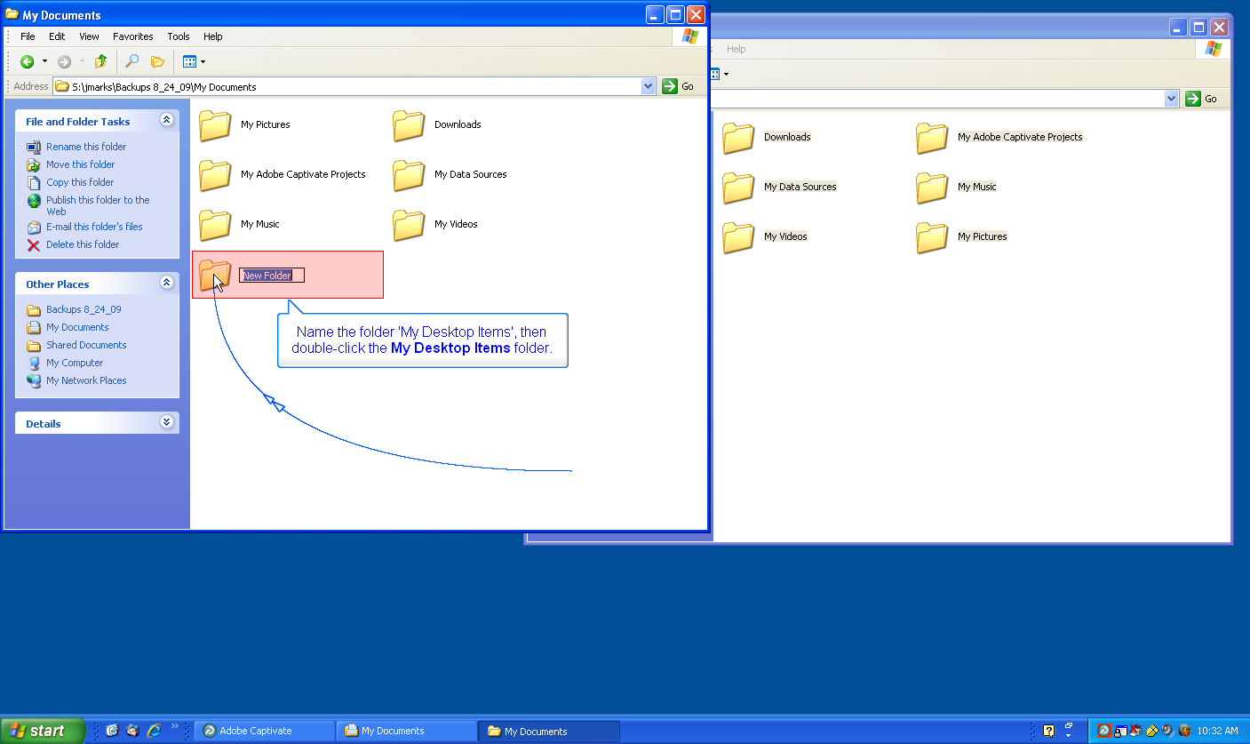

Name the folder 'My Desktop Items', then double-click the My Desktop Items folder.

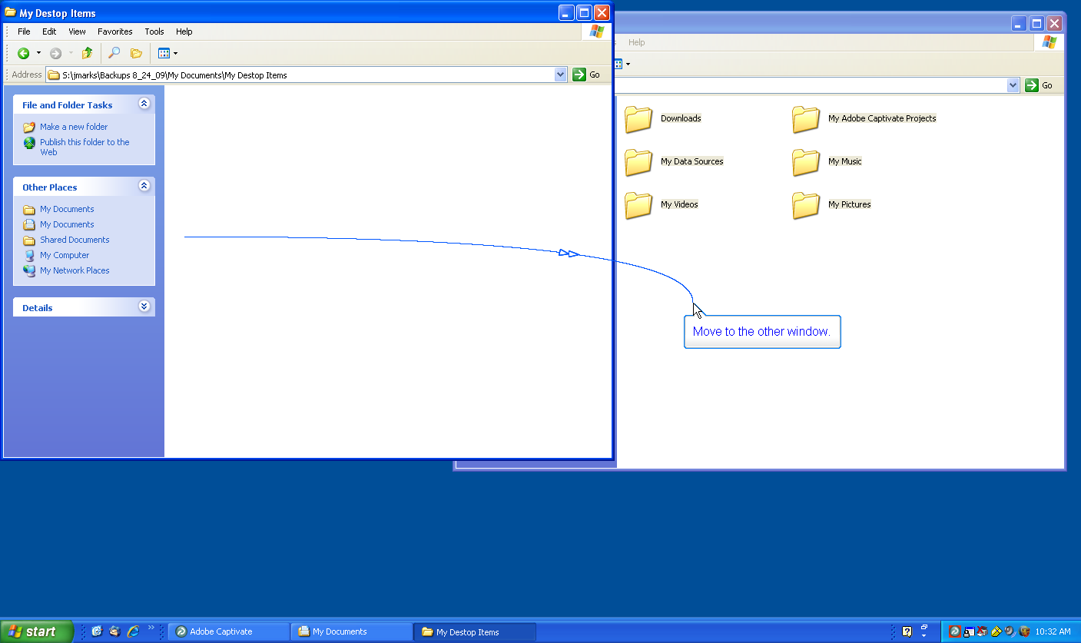

Move to the other window.

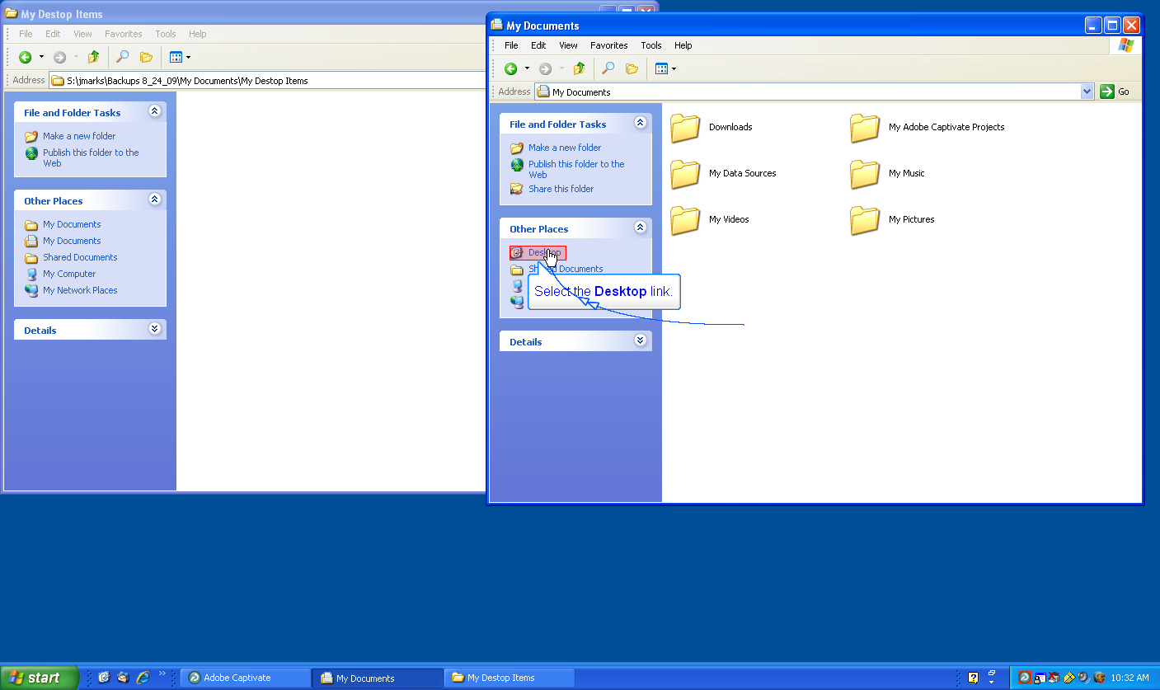

Select the Desktop link.

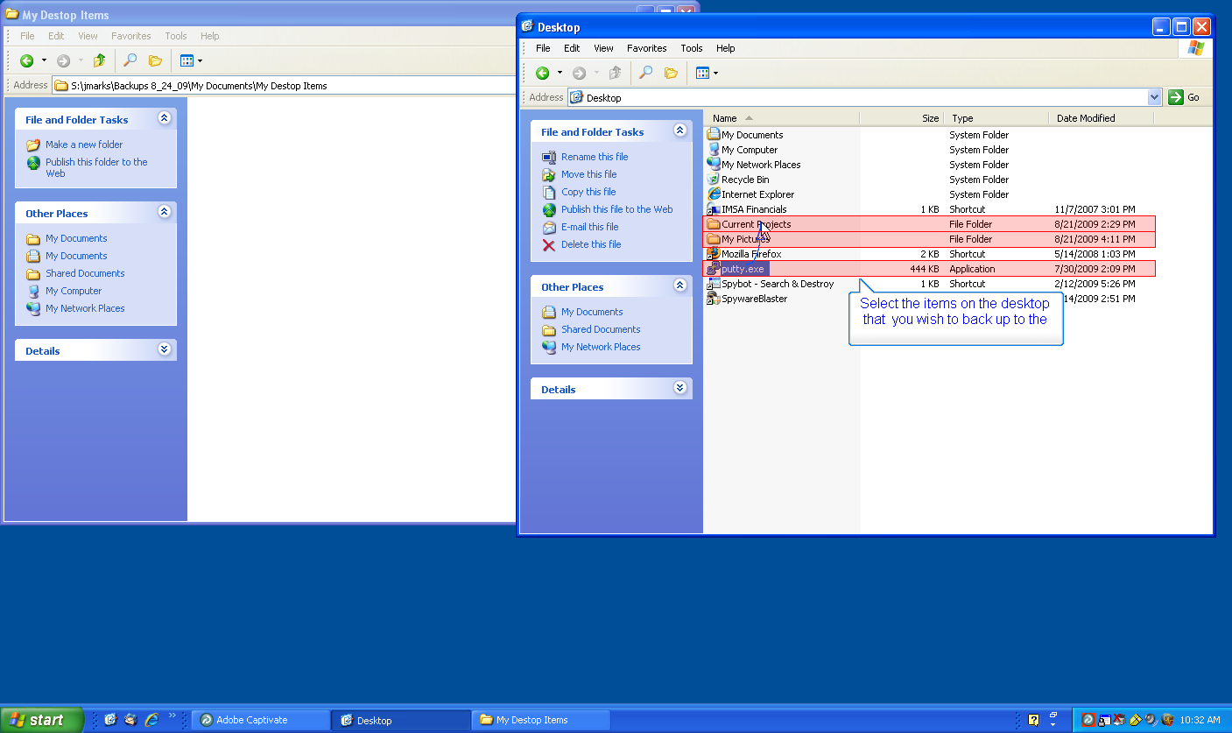

Select the items on the desktop that you wish to back up to the network.

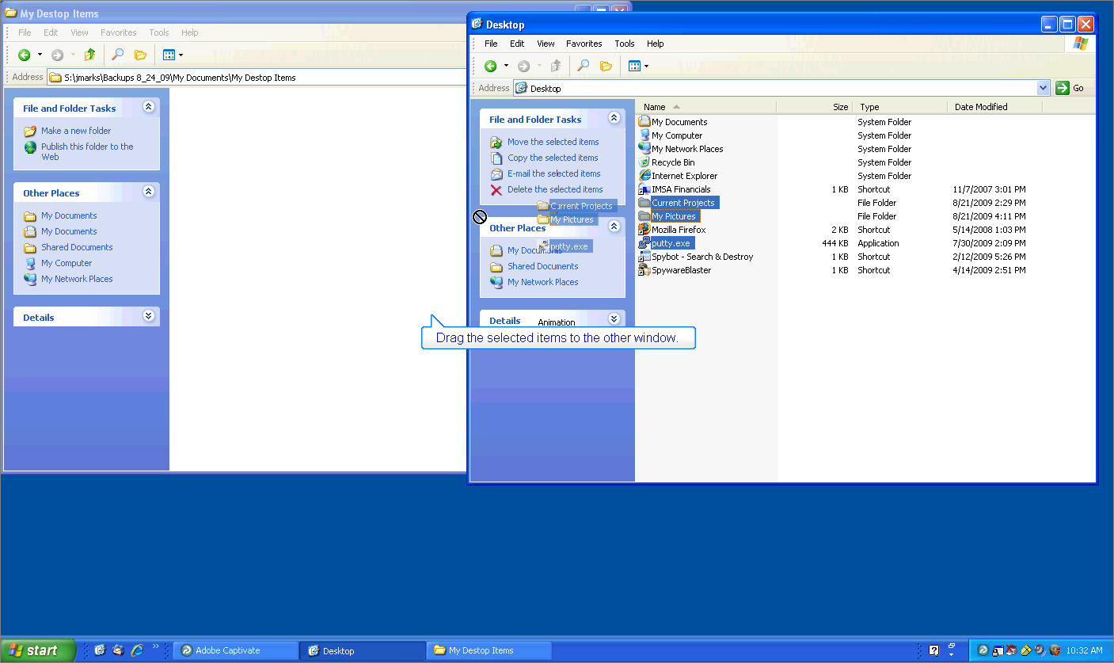

Drag the selected items to the other window.

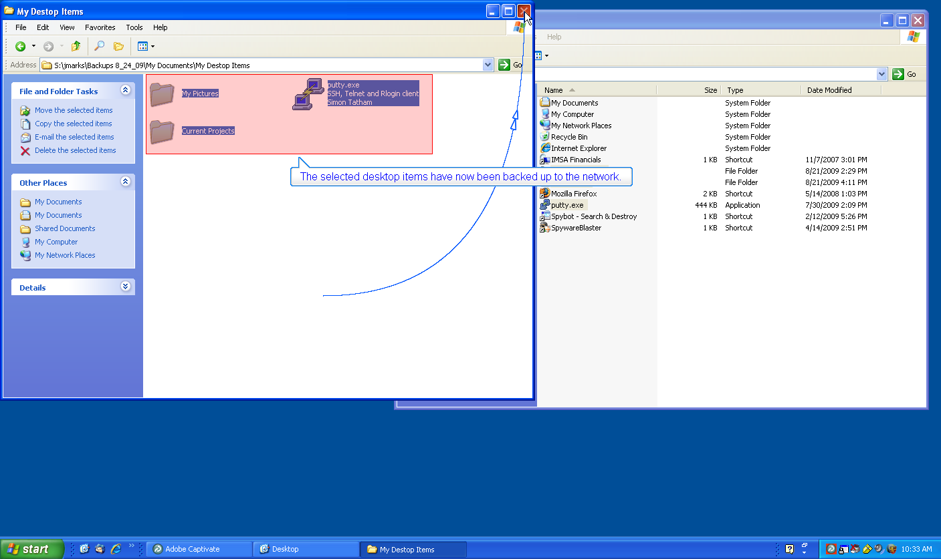

The selected desktop items have now been backed up to the network.

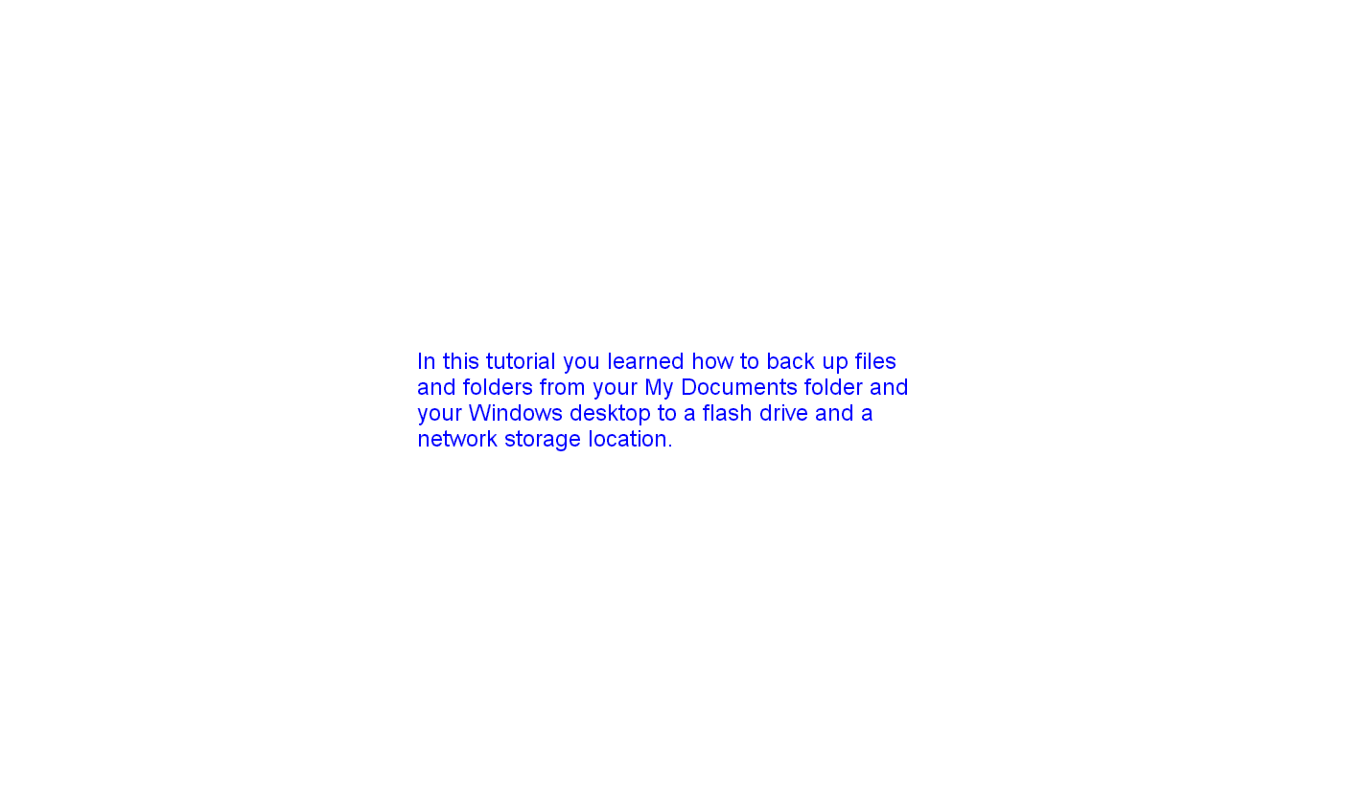

In this tutorial you learned how to back up files and folder from your My Documents folder and your Windows desktop to a flash drive and a network storage location.

